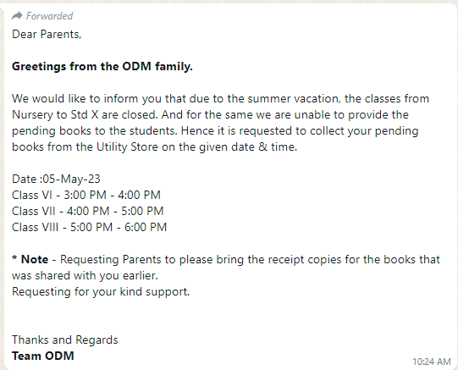**N.B. - Notice sent on dt. 04.05.2023 through school WhatsApp group**.