CHAPTER 08
REDOX REACTIONS

Very short answer type questions:-
01. What do you mean by electrode potential?
02. Assign oxidation number to the underlined elements in each of the following species:
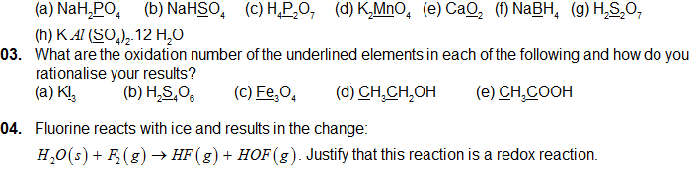
05. Arrange the following metals in the order in which they displace each other from the solution of their salts. AI, Cu, Fe, Mg and Zn.
06. Write the names of isotopes of hydrogen. What is the mass ratio of these isotopes?
07. How can the production of dihydrogen, obtained from coal gasification’, be increased?
08. Among NH3, H2O and HF, which would you expect to have highest magnitude of hydrogen bonding and why?
09. What causes the temporary and permanent hardness of water?\
10. How does H2O2 behave as a bleaching agent?
Short answer type questions:-
11. What do you understand by the term “non-stoichimetric hydrides”? Do you expect this type of the hydrids to be formed by alkali metals? Justify your answer
12. How do you expect the metallic hydrides to be useful for hydrogen storage? Explain.

13. How does the atomic hydrogen or oxy-hydrogen torch function for cutting and welding purposes? Explain.

14. Compare the structures of H2O and H2O2.

15. What do you understand by the term ‘auto-protolysis’ of water? What is its significance?
16. In the reactions given below, identify the species undergoing oxidation and reduction:
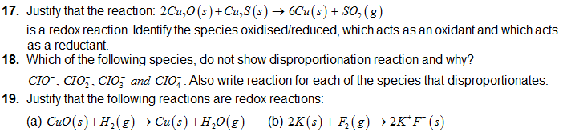
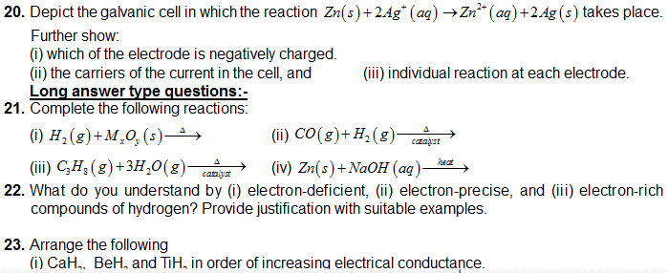
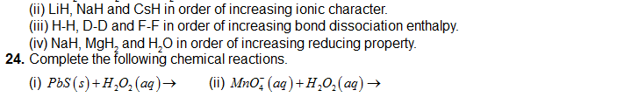
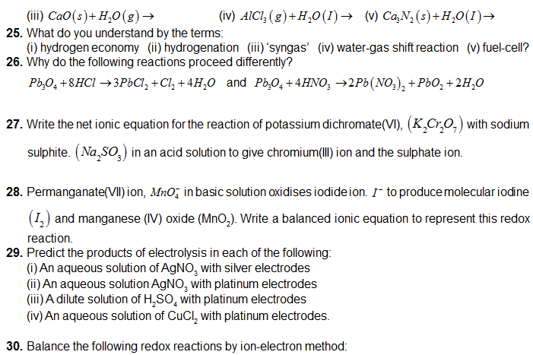
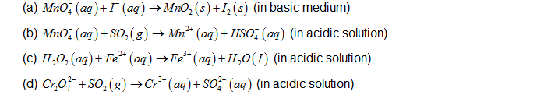
MODEL QUESTIONS:
Short answer type questions:-
01. Discuss the principle and method of softening of hard water by synthetic ion-exchange resins.
02. Write chemical reactions to show the amphoteric nature of water.
03. Write chemical reactions to justify that hydrogen peroxide can function as an oxidising as well as reducing agent.
04. Is demineralised or distilled water useful for drinking purposes? If not, how can it be made useful?
05. What is the difference between the terms ‘hydrolysis’ and ‘hydration’?
06. Write formulas for the following compounds:
(a) Mercury(II) chloride
(b) Nickel(II) sulphate

