Chapter- 9  
Ray Optics and Optical Instruments

**REFLECTION AT PLANE AND SPHERICAL SURFACES**

**LAWS OF REFLECTION**

Reflection of light is the process of deflecting a beam of light. A light ray incident on a surface is described by an angle of incidence ($∠i$). This angle is measured relative to a normal,a line perpendicular to the reflecting surface at the point of incidence (0). Similarly, the reflected ray is described by an angle of reflection ($∠r$), also measured from the normal as shown in Fig.

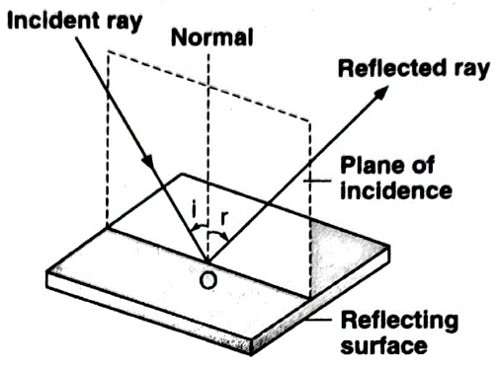

**Laws of Reflection**

**Law 1 :** The incident ray, the reflected ray and the normal, all lie in the same plane, called the plane of incidence. The incident and reflected rays are on the opposite sides of the normal.

**Law 2 :** The angle of incidence is always equal to the angle of reflection. That is, $∠i=∠r$

**Regular and Irregular Reflection**

|  |  |
| --- | --- |
|  |  |
| Reflecting surface is smooth and the reflected rays from parallel incident rays are also parallel. | Reflecting surface is rough and the reflected rays from parallel incident rays are not parallel. |

**Question-1:** Light incident normally on a plane mirror attached to a galvanometer coil retraces backwards as shown in Fig. A current in the coil produces a deflection of 3.5° of the mirror. What is the displacement of the reflected spot of light on a place 1.5 m away?

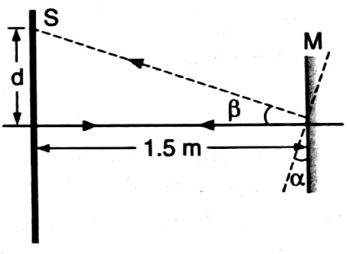

**Solution:** If $β$ is angle through which the reflected ray gets deflected when the minor M is deflected through an angle $α$, $β$ = 2 $α$. As $α$ = 3.5°, $β$ = 2 x 3.5° = 7°

Ifd is the displacement of the reflected spot of light on the screen S, then

$\tan{β}$ = $\frac{d}{1.5}$

$⟹$ d= (1.5) tan 7° Thus, d=18.42 cm

**Reflection of Light by Spherical Mirrors**

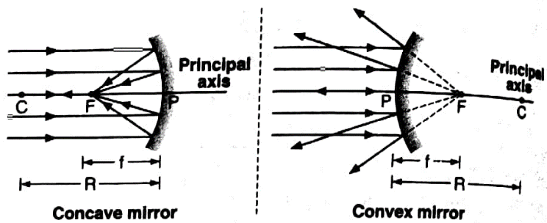

**New Cartesian Sign Convention for Spherical Mirrors**

|  |  |
| --- | --- |
|  |  |

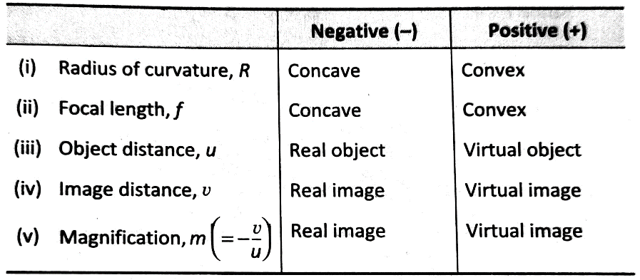

**Mirror Formula**

An equation connecting u, v and f in case of a mirror is called the Mirror Formula.

**Concave Mirror**

In the given figure.

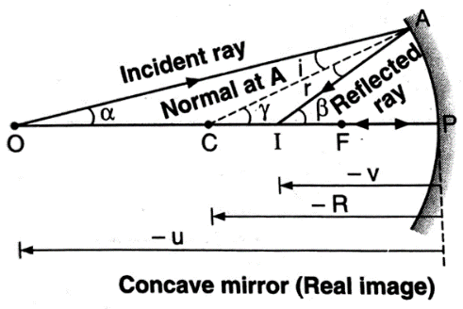

In $∆OAC$, $i=γ-α$

In $∆IAC$, $r=β-γ$

Since $i=r,$ $γ-α=β-γ$

Or $2γ=β+α$……. (1)

Expressing small angles $α, β and γ$ in circular measure, the common arc being approximately AP, from eqn. (1),

$2\frac{AP}{PC}=\frac{AP}{PI}+\frac{AP}{PO}$

or $\frac{2}{PC}=\frac{1}{PI}+\frac{1}{PO}$

Applying sign convention,

$PC=-R, PI=-v, PO=-u$, we get

$$\frac{2}{-R}=\frac{1}{-v}+\frac{1}{-u}$$

Or $\frac{2}{-R}=\frac{1}{-v}+\frac{1}{-u}$

Since $R=2f,$ $\frac{2}{2f}=\frac{1}{v}+\frac{1}{u}$

Or $\frac{1}{f}=\frac{1}{v}+\frac{1}{u}$

**Note:** Similarly it can be proved for convex mirror.

**Magnification (Linear) Produced by A Spherical Mirror**

Magnification produced by a spherical mirror is defined as the ratio of the site of the image (*I*) produced by the spherical mirror to the size of the object (*O*).

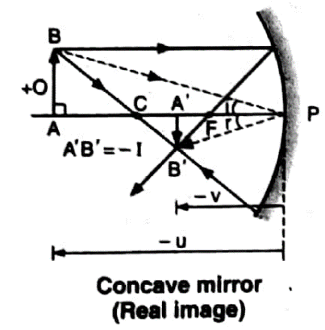

Magnification, $m=\frac{I}{O}=\frac{A^{'}B^{'}}{AB}$

In $∆ABP$ and $∆A^{'}B^{'}P^{'}$,

$∠ABP$ = $∠A^{'}B^{'}P^{'}$ (as i = r)

= (900each)

Tringles are similar.

$\frac{A^{'}B^{'}}{AB}=\frac{{PA}^{'}}{PA}$…… (1)

Applying sign convention,

$$A^{'}B^{'}=-I,AB=+O,PA=-u, PA^{'}=-v$$

From eqn (1)

$$\frac{-I}{+O}=\frac{-v}{-u}$$

$$\frac{I}{O}=-\frac{v}{u}$$

$$m=\frac{I}{O}=-\frac{v}{u}$$

**Note:**

* Plan mirror is a spherical reflecting mirror for which $f=∞$ and $R=∞$.

Using mirror formulae $\frac{1}{f}=\frac{1}{v}+\frac{1}{u}$

$$\frac{1}{∞}=\frac{1}{v}+\frac{1}{u}$$

$$v=-u$$

$$∴m=\frac{-v}{u}=1$$

* Relative velocity between object and image

$$v_{OM}=velocity of the object w.r.t mirror along its axis=\frac{du}{dt}$$

$$v_{IM}=velocity of the image w.r.t mirror along its axis=\frac{dv}{dt}$$

$$v_{IO}=velocity of the image w.r.t object=v_{I}-v_{O} or v_{IM}- v_{OM}$$

From mirror formulae $\frac{1}{f}=\frac{1}{v}+\frac{1}{u}$

$$⟹\frac{d}{dt}\left(\frac{1}{u}\right)+\frac{d}{dt}\left(\frac{1}{v}\right)=\frac{d}{dt}\left(\frac{1}{f}\right)$$

$$⟹\left(\frac{-1}{u^{2}}\right)\frac{du}{dt}-\left(\frac{1}{v^{2}}\right)\frac{dv}{dt}=0$$

$$⟹\left(\frac{-1}{u^{2}}\right)v_{OM}-\left(\frac{1}{v^{2}}\right)v_{IM}=0$$

$$⟹v_{OM}=-\frac{v^{2}}{u^{2}}v_{IM}$$

For plane mirror $v_{OM}=-v_{IM}$

* Number of images formed when two plane mirrors are inclined at an angle $θ$.

$n=\frac{360}{θ}$, if $\frac{360}{θ}$ is odd

$n=\frac{360}{θ}-1$, if $\frac{360}{θ}$ is even

**NUMERICALS ON MIRROR FORMULA**

**Question-1:**An object is placed (i) 10 cm (ii) 5 cm in front of a concave mirror of radius of curvature 15 cm. Calculate the position, nature and magnification of the image in each case.

**Solution:**

(i) Here, f = focal length = —15/2 cm = — 7.5 cm

u objectdistance = — 10 cm

$$\frac{1}{f}=\frac{1}{v}+\frac{1}{u}$$

$$\frac{1}{-7.5}=\frac{1}{v}+\frac{1}{-10}$$

$$\frac{1}{v}=\frac{1}{10}-\frac{1}{7.5}$$

$$v=-30 cm$$

Since v is negative, the image is real and is 30 cm from the mirror on the object side (i.e., in front of the mirror).

Magnification, $m=-\frac{v}{u}=-3$

Thus, the image is magnified and inverted.

(ii) Here, u = — 5 cm

$$\frac{1}{f}=\frac{1}{v}+\frac{1}{u}$$

$$\frac{1}{-7.5}=\frac{1}{v}+\frac{1}{-5}$$

$$\frac{1}{v}=\frac{1}{5}-\frac{1}{7.5}$$

$$v=15 cm$$

Since v is positive, the image is virtual and is 15 cm at the back of the mirror (i.e., not on the object side).

Magnification, $m=-\frac{v}{u}=+3$

Thus, the image is magnified and erect.

**Question-2:**A small candle 2.5 cm in size is placed 27 cm in front of a concave mirror of radius of curvature 36 cm. At what distance from the mirror should a screen be placed in order to receive a sharp image? Describe the nature and size of the image. If the candle is moved closer to the mirror, how would the screen have to be moved?

**Solution:***u*=-27 cm, *R* = - 36 cm, *f*= R/2 = -18 cm, O = 2.5 cm

$$\frac{1}{f}=\frac{1}{v}+\frac{1}{u}$$

$$\frac{1}{v}=\frac{1}{f}-\frac{1}{u}$$

$$\frac{1}{v}=\frac{1}{-18}-\frac{1}{-27}$$

$$v=-54 cm$$

As *v* is negative, the image is formed on the same side as the object. Thus, the screen should be placed at a distance of 54 cm from the mirror on the same side as the object.

$$\frac{I}{O}=-\frac{v}{u} \\ \frac{I}{2.5}=-\frac{-54}{-27}$$

$$I=-5 cm$$

Negative sign indicates that the image is inverted, realand magnified. When the candle is moved closer to the mirror, the image moves away from the mirror and as such the screen has also to be moved away from the mirror. Once the candle crosses the focus (i.e., the distance becomes less than f), the image formed would be virtual and hence cannot be obtained on the screen.

**Question-3:**A 4.5 cm needle is placed 12 cm away from a convex mirror of focal length 15 cm. Give the location of the image and the magnification. Describe what happens as the needle is moved farther from the mirror.

**Solution:***u* = - 12 cm,*f*= 15 cm, O = 4.5 cm

$\frac{1}{f}=\frac{1}{v}+\frac{1}{u}$

$$\frac{1}{v}=\frac{1}{f}-\frac{1}{u}$$

$$\frac{1}{v}=\frac{1}{+15}-\frac{1}{-12}$$

$$v=6.7cm$$

Positive value of *v* indicates that the image is virtual and is formed behind the mirror.

Magnification, $m=\frac{I}{O}=-\frac{v}{u}=\frac{20/3}{-12}=\frac{5}{9}$

Also, $I=\frac{5}{9}\left(4.5\right)=4.5 cm$

Thus, the size of the image is reduced.

As the needle moves farther from the mirror, the image moves towards the focus but never crosses it. It goes on diminishing in size.

**Note:** When $u=∞$

$$\frac{1}{v}=\frac{1}{f}-\frac{1}{∞}$$

$$v=f$$

Since *u* cannot be greater than $∞$, *v* cannot be more than *f*.

As $m=-\frac{v}{u}$, with increasing *u*, *m* decreases in magnitude.

As $u→∞, m→0$

**Question-4:** A thin rod of length f/3 is placed along the optic axis of a concave mirror of focal length f such that its image which is real and elongated, just touches the rod. What will be the magnification?

**Solution**: The image of the rod placed along the optical axis will touch the rod only when one end of the rod AC is at the centre of curvature of the concave mirror (PC =2f, AC = f/3). Then the image of the end C of the rod will be formed at the same point C.

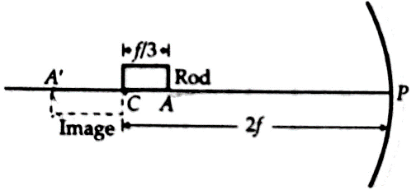

For the end A of the rod,

*u= PA= PC-AC =2f-(f/3) =5f/3*

From mirror formula,

$$\frac{1}{v}=\frac{1}{f}-\frac{1}{u}$$

$$\frac{1}{v}=\frac{1}{f}-\frac{3}{5f}$$

$$v=\frac{5f}{2}$$

PA’=5f/2

Length of the image *= A’C = PA’-PC = 5f/2 -2f=f/2*

Magnification =*CA’/CA=(f/2)/(f/3)=1.5*

**Question-5:** If you sit in a parked car, you glance in the rear-view mirror R=2m and notice a joggerapproaching. If the jogger is running at a speed of 5 m/s, how fast is the image of the jogger moving when the jogger is(a) 39 m (b) 29 m (c) 19 m (d) 9 m away?

**Solution:** As the rear-view mirror is convex,

so R=+2 m, f = R/2 =+1m

Froth mirror formula,

$$\frac{1}{v}=\frac{1}{f}-\frac{1}{u}$$

When u=-39m, v=39/40 m

As the jogger moves at a constant speed of 5m/s the position of the jogger after 1s,

u = -39+5 = -34 m

Position of the image after 1 s,

v'= (34/35) m

Difference in the position of the image in 1 s is

v - v' = 1/280 m

Average speed of the image = (1/280) m/s

Similarly, for u = -29 m, -19 m and 9 m, the speeds of image will be

(1/150) m/s, (1/60) m/s and (1/10) m/s.

**REFRACTION OF LIGHT**

**LAWS OF REFRACTION**

***The bending of a ray at the interface of two media is called refraction.***

The bending or the change in direction of propagation of light occurs except when it strikes the interface normally, *i.e.*, when angle of incidence, i = $0^{0}$

**Law 1 : *The incident ray (AO), the normal to the interface at the point of incidence and the refracted ray (OB), all lie in the same plane.***

**Law 2 : *The ratio of the sine of the angle of incidence to the sine of the angle of refraction is always a constant (a different constant for a different set of media).***

**That is, sin i/sin r = constant = 1µ2 …(1)**

Eqn. (1) is known as **Snell's law**. The constant **1µ2**  is called the *refractive index of medium-2with respect to medium-1when a ray of light travels from medium-1 to medium-2.* In other words, **1µ2** is the refractive index of the medium in which the refracted ray lies w.r.t the medium in which the incident ray lies.

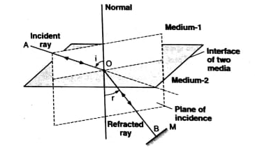

**Fig 1**

According to the **principle of reversibility of light,** if the final path of a ray of light, which has suffered a number of reflections and refractions is reversed, the entire ray retraces its path. Thus if we place a mirror at *M*  at an angle 900 to the refracted ray OB then BO will become the incident ray and OA will be the refracted ray. In such a case,

Angle of incidence =’r’ and angle of refraction =’i’

Thus, sin r/sin i= **2µ1 ….(2)**

From eqns. (1) and (2),

**1µ2 = 1/ 2µ1 or 2µ1 X 1µ2 = 1 ….(3)**

**Absolute Refractive Index**

Whenever light travels from one medium to another, its speed changes. The speed of light is maximum in vacuum and is given by c=3x108 m/s. The speed of light in another medium will be less than c, say equal to v. We define the refractive index of this medium to be

µ = (speed of light in vacuum)/(speed of light in medium) = c/v ……(4)

µ = **absolute** (or **standard**) **refractive Index**. Since v is less than c, µ is greater than 1. As the refractive index of air is almost unity (=1.00029), we can define the refractive index of a medium w.r.t. air instead of vacuum.

**Note**

1. Refractive index is a measure of speed of light in a transparent medium or technically a measure of the **optical density** of the material. For example, the speed of light in water is less than that in air, so water is said to be optically denser. Optical density in general correlates with mass density. However, in some cases, a material with greater optical density than another can have a lower mass density, *eg, mass density of turpentine oil is less than that of water but its optical density is higher.*
2. Greater the refractive index of a material, the greater is the material's optical density and the smaller is the speed of light in that material (as v= c/ µ).

**Relative refractive index**

Suppose the speed of light in medium-1 is v1, and that in medium-2 is v2. Thus, the corresponding refractive indices µ1 and µ2 , are

µ1 = c/v1 and µ2 = c/ v2

or µ1 v1 = µ2 v2

or µ2/ µ1 = v1/ v2 = **1µ2** ………(5)

*The relative refractive index of medium-2 with respect to medium-1 (ie. 1µ2) Is equal to the ratio (µ2/ µ1)of the absolute refractive indices µ1 and µ2 of the new media, I and 2.*

From eqns. (1) and (5)

sin i/sin r =µ2/ µ1

or µ1 sin i = µ2 sin r …..(6)

***The product of the refractive index and the sine of the angle made by the ray with the normal at the point of incidence is constant for a given ray in both the media.***

***This is the general statement of Snell's law.***

**Relationship between Refractive Index of a Material and the Wavelength of Light**

The speed of light waves may be different in different media but the frequency ($ν$) does not change (as it is characteristic of the source of light) when the wave propagates from one medium to another. This means that for the relation $ν$ = c/λ to hold good, its wavelength must change. Suppose the wave motion of frequency $ν$, wavelength λ1 and velocity v1 passes from medium-1 to medium-2, where the corresponding quantities are , λ and v2 . Let the refractive indices of the two media be µ1 and µ2 , and respectively. Thus,

v1 = λ1  and v2 = λ2

or λ2/ λ1 = v2/v1 = (c/µ2)/(c/ µ1) = µ1/ µ2

or µ1 λ1 = µ2 λ2 ……(7)

If the medium-1 is vacuum, then µ1= 1 and λ1= λ0  (say),

Clearly, 1 X λ0 = µ2 λ2 or λ2 = λ0/µ2

Or µ2 = λ0/ λ2

In general,

µ = λ0/ λ ….(8)

**Note:**

1. Refractive index depends upon the wavelength; that is, µ varies with the colour of light, even though the variation is small. For example, the refractive indices of glass for red, green and violet light are 1.51, 1.52 and 1.53 respectively.
2. Refractive index of medium-2 w.r.t. medium-1, i.e.

1µ2 = µ2/ µ1 = v1/v2 = λ1/ λ2 …..(9)

**Dependence of refractive index of a medium on wave length :**

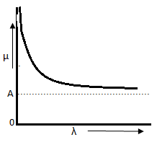Cauchy’s formula gives the dependence of refractive index of a medium on wavelength . This is given as;

 

It is some how also written as ; 

* So if red , blue and green colour light enter normally into

a glass slab at a time , then as 

 ( By Cauchy’s law )

 ( Since µ=c/v)

 ( Since t = d/v )

So red colour emerges out earliest , then green and finally blue .

**Relation between real depth and apparent depth**

Consider an object O in the denser medium.

An incident ray OA goes undeviated into the rarer medium.

Another ray of light OB bends away from the normal and appears to meet ray OA at I.

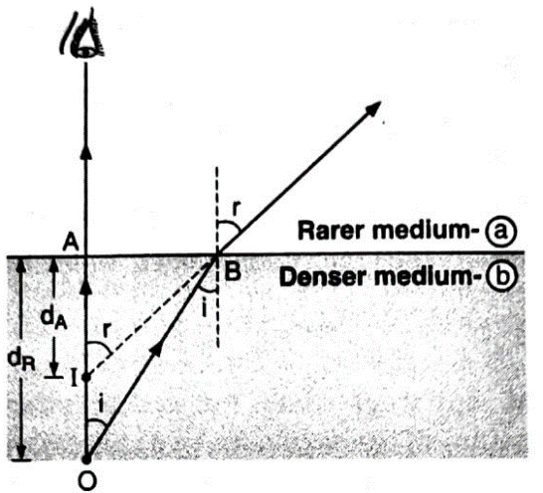I isthe virtual image of the object O.

O appears to be raised to the position I.

OA = real depth

IA = apparent depth

$${}_{a}^{b}μ=\frac{\sin{i}}{\sin{r}}=\frac{AB/OB}{AB/IB}=\frac{IB}{OB}$$

$${}_{b}^{a}μ=\frac{1}{{}_{a}^{b}μ}=\frac{OB}{IB}$$

For small angle of incidence OB $≈$ OA and IB $≈$ IA. Therefore, ${}_{b}^{a}μ=\frac{OA}{IA}=\frac{real depth}{apparent depth}$

**Note:** Displacement of the image $d_{R}-d_{A}=d_{R}\left(1-\frac{d_{A}}{d_{R}}\right)=d_{R}\left(1-\frac{1}{{}_{b}^{a}μ}\right)$.

**Atmospheric Refraction**

The refraction of light through the atmosphere is called atmospheric refraction.

**(a) Advance Sunrise and Sunset:** The Sun is visible before actual sunrise and after actual sunset because of the atmospheric refraction. It occurs because as we go higher up from the Earth, the density and the refractive index of the air layers decrease. The rays of light from the Sun keep on bending towards the normal. When the Sun S is below the horizon HH', it appears to be at S’ [Fig].

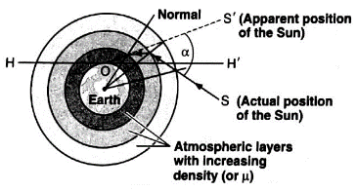

The angle $α$ through which the Sun or any other celestial body is apparently raised is called atmospheric refraction.

**(b) Flattened appearance of the Sun or the Moon at rising or setting:** The apparent raising due to refraction is greater for positions near the horizon. When the Sun or the Moon is nearer the horizon, the lower side along the vertical diameter appears to be raised more than the upper side while the two extremities along a horizontal diameter are raised to the same extent. Consequently, the vertical diameter appears to be shortened and so the disc of the Sun (or the moon) appears to be somewhat elliptical or flattened.

**(c) Twinkling of Stars:** The refractive index of air varies periodically even at the same level. A star appears to twinkle as the rays of light from it are sometimes concentrated at a point and sometimes decrease inintensity. The planets being nearer, the amount of light received from them is greater and so the variation in brightness is not appreciable. Obviously, no twinkling is observed in case of planets.

**Numericals**

**Question-1**: Fig. shows refraction of an incident ray in air at 60° with the normal to a glass-air and water-air interface respectively. Predict the angle of refraction of an incident ray in water at 45° with the normal to a water-glass interface.

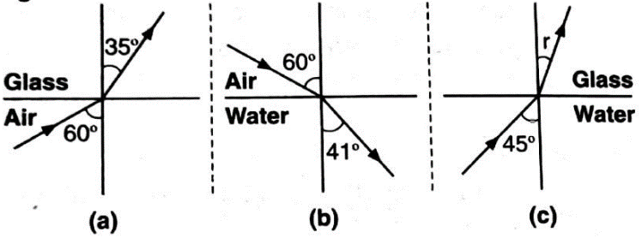

**Solution**:

In Fig. (a), as light travels from air to glass,

$${}_{g}^{a}μ=\frac{\sin{{60}^{0}}}{\sin{{35}^{0}}}=\frac{0.8660}{0.5736}=1.51$$

In Fig. (b), as light travels from air to water

$${}_{w}^{a}μ=\frac{\sin{{60}^{0}}}{\sin{{41}^{0}}}=\frac{0.8660}{0.6551}=1.32$$

In Fig. (c), as light travels from water to glass,

$${}_{g}^{w}μ=\frac{{}_{g}^{a}μ}{{}_{w}^{a}μ}=\frac{1.51}{1.32}=1.144$$

$$\frac{\sin{i}}{\sin{r}}=1.144$$

$$\sin{r}=\frac{\sin{{45}^{0}}}{1.144}$$

$$r={38.2}^{0}$$

**Question-2**: A tank is filled with water to a height of 12.5 cm. The apparent depth of a needle lying at the bottom of the tank is measured by a microscope to be 9.4 cm. What is the refractive index of water? If water is replaced by a liquid of refractive index 1.63 up to the same height, by what distance would the microscope have to be moved to focus on the needle again?

**Solution:** Refractive index, of water,

$${}_{w}^{a}μ=\frac{real depth}{apparent depth}=\frac{12.5}{9.5}=1.33$$

Refractive index of Liquid

$${}_{l}^{a}μ=\frac{real depth}{apparent depth}=1.63$$

Real Depth = 12.5 cm

1.63=(12.5/Apparent Depth)

Apparent Depth = 7.7 cm

The image of the needle moves up and microscope has to be moved up to keep the image in focus.

Distance through which the microscope has to be moved up = 9.4cm-7.7cm=1.7cm

**TOTAL INTERNAL REFLECTION**

In the figure give below a ray meets the surface XY separating a denser medium (b) and a rarer medium (a) at a small angle of incidence i.

The angle of refraction r is greater than the angle of incidence i.

If the angle of incidence is increased, it will reach a critical value, where the angle of refraction is just 90" and the refracted ray grazes along the surface of denser medium.

|  |  |
| --- | --- |
|  |  |
|  |  |

**The critical angle (ic) between two media is the angle of incidence in the optically denser medium for which the angle of refraction is 90°.**

When i > ic, no light emerges and all the light is totally internally reflected. This phenomenon is called total internal reflection.

**The total internal reflection (TIR) is the phenomenon in which a ray of light travelling from an optically denser medium into an optically rarer medium at an angle of incidence greater than the critical angle for the two media is totally reflected hack into the same medium.**

Thus, the conditions for TIR are :

(a) Light is travelling from optically denser to optically rarer medium.

(b) The angle of incidence at the surface is greater than the critical angle for the pair of media.

**Relation between Critical Angle and Refractive Index**

From Snell's law,

$$\frac{\sin{i}}{\sin{r}}={}_{a}^{b}μ$$

When i=ic , r= 900

Thus,

When medium (a) is air, then ${}_{b}^{a}μ=µ$

$$\sin{i_{c}}=\frac{1}{µ}$$

**Note:**

1. For water, $µ$ = 1.33,

$\sin{i_{c}}=$ 1/ 1.33=0.7519

ic = 48.75°

1. For crown glass $µ$ = 1.52

ic= 41.14°

**Applications of TIR**

1. **Sparkling of Diamonds**

|  |  |
| --- | --- |
| * High refractive index (2.41) of diamond leads to its small critical angle in air of 24.5°. * Diamonds are skillfully cut with many faces in such a way that much of the incident light undergoes multiple total internal reflections within the diamond before passing out again in the air. * Like a prism, diamond is a dispersive material (that is $µ$ varies somewhat with λ), and so the various colours composing white light travel somewhat different paths and emerge in different directions. Hence, diamond sparkles. |  |

1. **MIRAGE**

* The sighting of inverted images on hot still summer days is called mirage as it gives an illusion of water due to inverted images of trees, etc., especially in deserts.
* The phenomenon is on account of the combined effect of:
  + (i) successive refractions at various layers of air having different values of $µ$
  + (ii) total internal reflection
* The ray of light from the top A of an object progressively bends away from the normal till it reaches point B where the angle of incidence is greater than the corresponding critical angle.
* At this stage, the ray is totally reflected upwards and appears to come from point A' giving rise to an imaginary image OA' of the object OA.

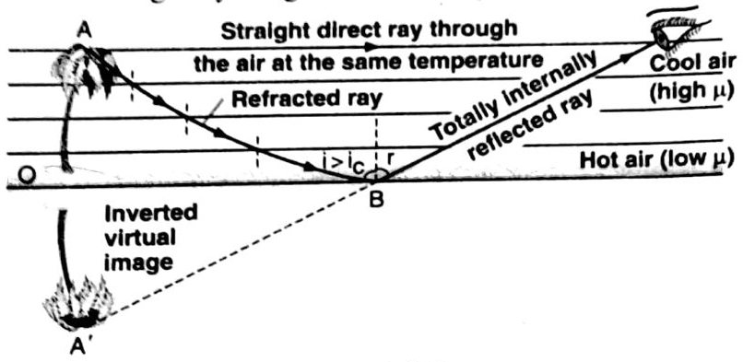

1. **PRISM**

* A prism so designed that its angles are 450, 450, 900; is said to the total reflection prism or totally reflecting prism or the right-angled prism.

|  |  |  |
| --- | --- | --- |
|  |  |  |

* The critical angle of glass is about 410. In such a prism, the rays are so directed that the angle of incidence at the surface where TIR occurs is 450.
* Hence, the ray of light will be totally reflected.
* A total reflection prism can be used as a mirror producing deviation of 90° or 180° or no deviation at all as in case of the erecting prism.

1. **OPTICAL FIBRE**

* An optical fibre is an extremely thin (about 50 $µ$ m in diameter) long strand of high quality glass or quartz (called core) which is coated with a thin layer of a material of lower refractive index (called cladding).
* It works on the principle of total internal reflection.

|  |  |
| --- | --- |
|  |  |

* A light ray travelling within the fibre is internally reflected each time it strikes the surface between the core andthe cladding so long its angle of incidence exceeds the critical angle for the core-cladding.
* core = 1.6

cladding = 1.5

ic = 700

= 0.94

* A bundle of fibres is called a light pipe and may contain about 104 fibres.
* Optical Fibres are used in endoscopy, arthroscopic surgery, laser angioplasty etc.

**Numericals**

**Question-1:** A small bulb is placed at the bottom of a tank containing water to a depth of 80 cm. What is the area of the surface of water through which light from the bulb can emerge out? Refractive index of water is 1.33. Consider the bulb to be a point source.

**Solution:**

S = small bulb

SO = d= 80 cm = 0.8 m

Rays of light incident at an angle greater than ic, are totally reflected within water and consequently cannot emerge out of the water surface.

|  |  |
| --- | --- |
| $$\sin{i_{c}}=\frac{1}{µ}=\frac{1}{1.33}=0.75$$ $$i_{c}=48°36'$$ $$\tan{i_{c}}=\frac{r}{d}$$ $$r=d\tan{i_{c}}$$ $$r=0.91 m$$ Area of the circular path = r2 =3.14 x (0.91m)2 = 2.6 m2 |  |

**Question-2:** In the Fig. given below shows a cross-section of a light-pipe made of a glass fibre of refractive index 1.68. The outer covering of the pipe is made of a material of refractive index 1.44.

(a) What is the range of the angles of the incident rays with the axis of the pipe for which total reflections inside the pipe take place as shown?

(b) What is the answer if there is no outer covering of the pipe?

**Solution:***Left to the Students*

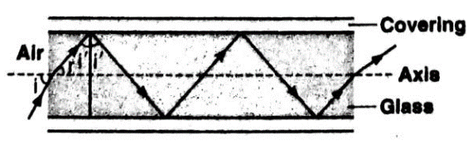

**Refraction at single spherical surface :**

**Assumptions :** To proceed to derive equation of refraction at single spherical surface the assumption taken are ;

1. The spherical surface have small aperature
2. Object is on the principal axis .
3. All the rays from object are paraxial rays .
4. All angles like angle of incidence ( i) , angle of refraction (r) , angle by incident ray with principal axis (α), angle by refracted ray with principal axis (β) and angle by incident ray with principal axis (γ) are very small such that these angles tend to zero. So the sine and tangent of these angles tend to the radian value of the angles .

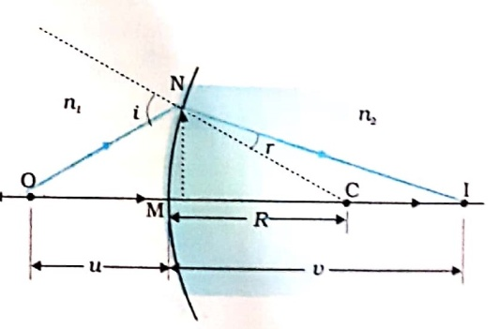**Derivation of equation of refraction :**

A spherical surface of radius of curvature R separates two media of refractive indices n1 and n2 . Object O is in the medium n1 and its real image I is produced in medium n2 obeying laws of refractions .

Let 

As per the assumptions point M is very close to the pole of the spherical surface .

As per sign conventions ; MO = -u , MI = v and MC = R . ...(i)

Now by Snell’s law , at N ,



 ......(ii) ( Since )

In  NOC , = +  = α + γ tan α + tan γ

( Since )

............(iii)

Similarly in  NIC , =  + 



( Since )

 .........(iv)

Using equations (iii) and (iv) in equation (ii) we get ;





 ( Using the substitutions from equation (i)) . ... This is the equation of refraction .

This relation holds good for all types of spherical surfaces .

**Relation between apparent depth and real depth using refraction equation for spherical surface :**

For plane surface R = ∞

Object is in denser medium refractive index µ and real depth = u and apparent depth = v

Light travels from µ 1 i.e air

By equation of refraction ; 

Using the substitutions of this case ; 



**Numericals : Light from a point source in air falls on a spherical glass surface ( n = 1.5 and radius of curvature = 20 cm ) . The distance of the light source from the glass surface is 100 cm . At what position the image is formed ?**

**Solution :**

In this case , u = -100 cm as per sign conventions.

R = 20 cm

Light is travelling from air ( i.e. n = 1) to glass ( i.e. n = 1.5 )

So by equation of refraction ; 





So image is formed 100cm from the separating surface in the direction of light .

**Numericals : Rays of light parallel to a diameter of a glass sphere ( n = 1.5 and radius = 20 cm ) fall on it very close to the pole. Find the position w.r.t. centre of the sphere where the rays meet the principal axis of the sphere ?**

**Solution :** In this case at the first face ; u = - ∞ , R = + 20 cm and light travels from n =1 to n=1.5 .

So ,  from P1 in light direction i.e. 60cm -40 cm = 20 cm from P2 in light direction .

Hence for second surface ; u = + 20 cm , R = -20cm and light travels from n=1.5 to n = 1

So ; 

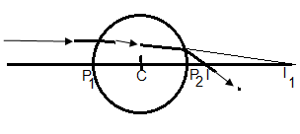 from P2 in the direction of light

Hence rays meet principal axis at 10 cm from second surface in light direction .

Hence distance from centre = 10 cm + 20 cm = 30 cm

**Lens :**

Lens is a refracting medium bounded by two spherical surfaces . As per the shapes of the two boundary surfaces the lens is named .

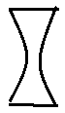

e.g. : (i) double convex (ii) double concave



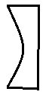 (iii) plano convex (iv ) plano concave etc .

**Some important terms related to lenses :**

1. 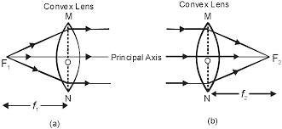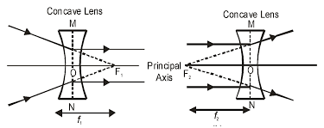**Principal Focus and focal lengths :** Lenses have two principal foci at two sides of lens i.e. 1st focus ( F1) and 2nd Focus ( F2 ) . For convergent lens , if u = - f1 , then v = ∞ and for divergent lenses, if u = f1 , then v = ∞ . Similarly . For convergent lens , if u = -∞ , then v = f 2 and for divergent lenses, if u = -∞ , then v = - f2 .
2. If both sides of lens have same medium then magnitude of both focal lengths are same and taken as f .
3. 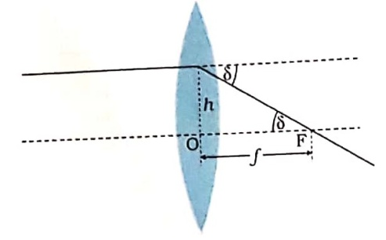**Power of lens :** Power of a lens is a measure of the convergence or divergence , which a lens introduces to the light falling on it .

Power of a lens is numerically equal to the tangent of the angle by which it converges or diverges a beam of light falling at unit distance from optical centre .

In the figure a beam parallel to principal axis strikes the lens at a height h .

From figure , δ = deviation angle

As tan δ = h/f . If h = unity , then tan δ = 1/f

So power of lens is ; **P = 1/f**

S.I. unit of power is dioptre (D ) and **1 D = 1m-1** .

**Lens maker’s formula :**

In a lens refraction occurs twice . One at 1st refracting face of lens ( from n1 to n2 ) and the second at the second refracting face of lens (from n2 to n1).

Now considering refraction at first face only ( i.e. figure b ) we have O is the object with image distance u and I1 is the image with image distance v1 .

So,  …….(i)

Now considering refraction at 2nd face only ( i.e. figure c ) we have I1 is the virtual object with object distance v1 and real image I with image distance v .

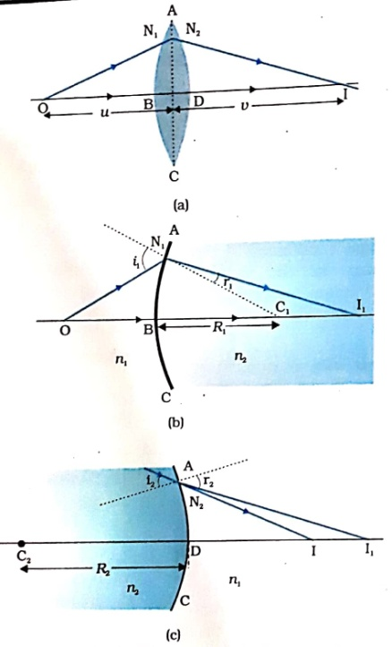So,  …….(ii)

Adding eqution (i) and (ii) we get , 



 ..(iii)

As both sides of lens have same medium so it has one focal length f .

If u = - f , then v = ∞ .

Using the condition in equation (iii) we get ,



…………. (iv)

Equation (iv ) gives Lens maker’s formula .

Comparing equation (iii) and (iv) we get , ………(v)

This equation (v) gives thin lens formula .

**Change of focal length and power of a lens by changing the surrounding medium :**

If surrounding medium changes then n1 changes .

From lens maker’s formula we have  …(i)

If n1 increases then

1. till n1 < n2 ; sign of R.H.S. does n’t change, so sign of f does n’t change . but f increses . Hence lens behaves as of its nature with greater focal length and less power .
2. When n1 = n2 ; then R.H.S. of equation = 0 . So 1/f = 0 i.e. P = 0 and f = ∞ . Hence the lens behaves as a plane glass slab and dissapears in the medium .
3. When n1 < n2 ; then  . Hence sign of R.H.S.of equation (i) changes and hence sign of f changes . Hence lens behaves opposite to its nature i.e. convex lens behavees as divergent lens and concave lens as convergent lens .

**Question : Draw the ray diagrm showing the refraction of parallel beams through a convex lens of refractive index n2 kept in the surrounding of refractive index n1 for (a) n1 < n2 (b) n1 = n2  (c) n1 > n2 .**

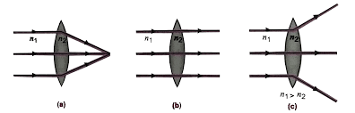**Answer :** (a) Lens is convergent

(b) Lens is as a plane sheet

(c ) Lens is divergent .

**Numerical : (a)If f = 0.5 m for a glass lens , what is the power of the lens ?**

**(b) The radii of curvature of a double convex lens are 10 cm and 15 cm . Its focal length is 12 cm . What is the refractive index of the lens ?**

**(c) A convex lens has focal length 20 cm in air ? What is its focal length in water ? ( Refractive index of glass is 1.5 and of water is 1.33 .)**

**Answer :** (a) P = 1/f = 1/0.5m= 2 D

(b) For conve lens ; R1 = + 10 cm nd R2 = -15 cm

As from lens maker’s formula we have 



(c) In air , ….(i)

In water ; ….(ii)

Now eqn. (i) divided by eqn. (ii) ; 



**Numerical : A bi- convex lens of radius of curvature R and refractive index n1 is kept in such a region that medium left to it is air and medium right to it has efractive index of n2 . Find is focal length . Obtain the condition when it behaves as divergent lens .**

**Answer :** For refraction at first face ,  …….(i)

For second face R2 = -R , So  …….(ii)

Adding equations (i) and (ii) we have ;  ……(iii)

Generally focal length means 2nd focal length . i.e. when u = - ∞ , v = f

Hence equation (iii) becomes ; 

. This is the expression for focal length .

Lens behaves as divergent lens if , f = -ve

This is possible if , 2n1 < n2 + 1

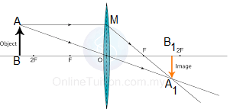**Derivation of thin lens formula :**

In the figure AB = object

A1B1 = Its real image drawn by obeying laws of refraction .

By sign conventions ; BO = -u

OB1 = v , OF = f

Now by geometry ; ABOΔ ~ A1B1O Δ ( Since  as opposite angles

And )

 …(i) ( By CPST )

Similarly by geometry ; MOFΔ ~ A1B1F Δ ( Since  as opposite angles And )

 …(ii) ( By CPST and as AB = MO )

From equations (i) and (ii) we have ; 



Dividing uvf in both sides ; 

 This is thin Lens formula .

**Linear magnification (m) :**

Linear magnification of a lens is defined as the ratio between image height ( hI) and object height ( hO ). i.e. 

Now by geometry ; ABOΔ ~ A1B1O Δ

 by CPST

Using sign convention ; 

 . This is the expression for linear magnification .

* **m in term of u and f :** As 

Again ; 

* **m in term of v and f :** As 

Again ; 

**Image formation by convex lens :**

|  |  |  |  |
| --- | --- | --- | --- |
| Position of object | Position of image | Nature of Image | Magnification |
| 1. At ∞ | At F | Real and inverted | Highly diminished |
| 1. Beyond -2F | Between F and 2F | Real and inverted | diminished |
| 1. On -2F | On 2F | Real and inverted | Same size |
| 1. Between -2F and F | Beyond 2F | Real and inverted | magnified |
| 1. On F | At ∞ | Real and inverted | Highly magnified |
| 1. Between F and lens | In the same side of object | Virtual and erect | magnified |

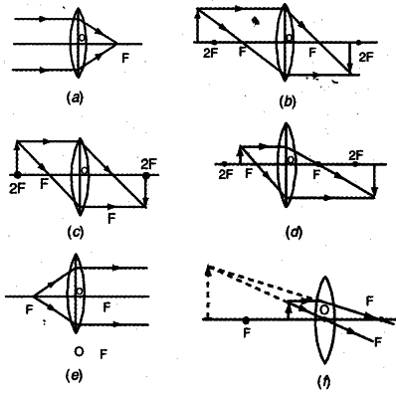

**Image formation by concave lens :**

|  |  |  |  |
| --- | --- | --- | --- |
| Position of object | Position of image | Nature of Image | Magnification |
| 1. At ∞ | At - F | Virtual and erect | Highly diminished |
| 1. At any finite position | Between – F and lens | Virtual and erect | diminished |

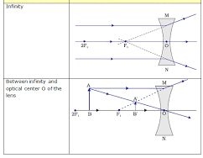

**Numerical : A beam of light converges at a point P . Now a lens is kept in the path of the convergent beam 12 cm from P . At what point does the beam converge if the lens is (a) a convergent lens of focal length 20 cm ? (b)a concave lens of focal length 16 cm ? (NCERT)**

**Solution :** This is the case of virtual object .

1. u = 12 cm , f = 20 cm

As; 

1. u = 12 cm , f = - 16 cm

As; 

**Numerical : Show that minimum distance between object and its real image by a convex lens is 4F. OR Show that maximum focal length to keep the object and real image distance at L is L/4 .**

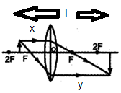**Solution :** Let u = - x and v = y

So distance between object and its real image is L = x + y

Hence y = L –x

By lens formula ; 



To have real solution of the equation condition to be satisfied is ;



So  OR 

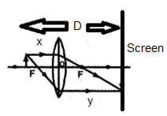**Numerical : An object is placed at a distance D from a screen . A convex lens is placed in between the object and screen . It is observed that for two positions of lens separated by a distance d . Find expression for the focal length of the lens .**

**Solution :** Let for a position of lens at distance x from object image be formed on the screen .

So by sign convention , u = -x and v = D - x

By lens formula ; 



Solutions of this quadratic equation represents two positions ( x1 and x2 ) of lens for producing image on the screen . As given , x2 - x1 = d





So image distance ; v = D-x = (D-d)/2 if x = (D+d)/2 and v = (D+d)/2 if x = (D-d)/2 .

So magnification ; m = (D-d)/(D+d) or m = (D+d)/(D-d)

**Power of lens :** Power of a lens is a measure of the convergence or divergence , which a lens introduces to the light falling on it .

Power of a lens is numerically equal to the tangent of the angle by which it converges or diverges a beam of light falling at unit distance from optical centre .

In the figure a beam parallel to principal axis strikes the lens at a height h .

From figure , δ = deviation angle

As tan δ = h/f . If h = unity , then tan δ = 1/f

So power of lens is ; **P = 1/f**

S.I. unit of power is dioptre (D ) and **1 D = 1m-1** .

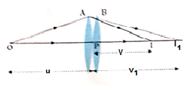**Two thin lenses in contact :**

In figure two thin lenses A and B of focal lengths f1 and f2 with powers P1 and P2 are in contact .

O is the object . I1 is the image for A and object for B . I is the image of B and image of the combination .

Now for lens A using lens formula , ….(i)

Now for lens B using lens formula , ….(ii)

Adding equations (i) and (ii) we get , ..(iii)

Since u = object distance for the combination and v = image distance of combination ,

Hence for the combination ;  …(iv) ( Where f = equivalent focal length of the combination )

Comparing equations (iii) and (iv) we get , 

Power of the combination is ; 

* For large number of lenses in contact ,  OR 

**Numerical : A combination of two lenses form two times magnified real image at a distance of 40 cm from the combination . If one of the lenses is convex with focal length 10 cm , then what is the nature and focal length of the second lens ?**

**Solution :** For combination ; v = 40 cm ( positive as real image ) and m = -2 ( as inverted )

Since , 

Now .

As , 

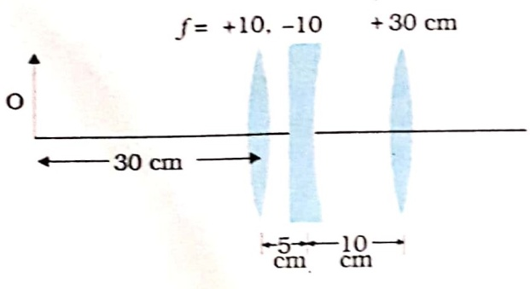So second lens is divergent lens with focal length 40 cm .

**Numerical : In the given combination of lenses find the final image position.**

**Solution :** For 1st lens ; u1 =- 30 cm and f1 = 10 cm

By lens formula ; 



Now for combination cases , image of first lens is the object of the second lens ‘

So for second lens ; u2 = v1 – d12 = 15 cm – 5 cm = 10 cm ( +ve because virtual object )

f2 = -10cm

By lens formula ; 



So for third lens ; u3 = v2 – d23 = ∞ – 10cm = ∞

F3 = 30cm

By lens formula ; 



So final image is produced 30 cm right to the third lens .

**Numerical : In the given combination of lenses , all lenses are identical with focal length 30 cm . I is the final image position of the object O . Find the distances between the lenses .**

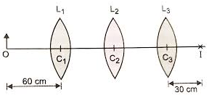**Solution :** For 3rd lens ; v3 = 30 cm and f3 = 30 cm

i.e. image is at the secod focus of the third lens . So the incident ray for thid lens must be parallel to principal axis . So u3 =∞ .

So what ever the separation between L2 and L3 may be for 2nd lens v2 = ∞ . Again f2 = 30 cm.

So object for 2nd lens must be at its 1st focus .

So u2 = - 30 cm .

For 1st lens ; u1 =- 60 cm and f1 = 30 cm

By lens formula ; 



So for second lens ; u2 = v1 – d12  d12 = v1 – u2 = 60 cm – (-30cm ) = 90 cm

So separation between L1 and L2 = 90 cm and separtion betwee L2 and L3 can be of any value .

**Numerical : A convex lens of focal length 30 cm and a convex mirror of radius of curvature 40 cm are kept coaxially at a separation 10 cm. A pont object O is kept on the principal axis such that image coincides the object . Draw the ray diagram and find the position of object .**

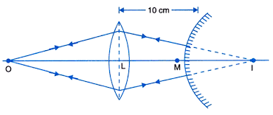**Solution :** The ray diagram is shown below .

As the refracted rays from lens are returning along same line that means the rays must be normal to the mirror i.e. approaching towards the centre of curvature .

Hence image of lens is the centre of curvature of the mirror .

Hence for the lens ; v = 10 cm + R of the mirror = 10 cm + 40 cm = 50 cm

And f = 30 cm

By lens formula ; 



Hence object is at 75 cm left of the convex lens .

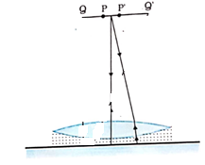**Numerical : In the given figure an equi-convex lens of refractive inde 1.5 is kept on a liquid of unkown efractive index on a plane mirror . In this situation a very small pin PQ is moved along the axis till its image coincide with it . This happens at a distance x from the combination . Now the same eperiment is repeated after removing the liquid and the distance of pin is found to be y. Find the refractive index of the unknown liquid .**

**Solution :** When a lens system is kept on a mirror and the image coincides with the object , then the refracted rays from the lens system must be normal to the mirror . As here mirror is plane mirror , hence normal to this means parallel to the principal axis of the lens system . So refracted rays of the lens system are parallel to the principal axis .

Hence object is at the 1st focus of the lens .



Here f is the focal length of the lens system i.e. the equi-convex lens( focal length f1) in contact with the plano-concave lens ( focal length f2 ) formed by the liquid and lens .

Hence  …….(i)

When the liquid is removed then only convex lens remains . Here he observed distance is y .

Hence focal length of the lens is y

 …….(ii)

Using equation (ii) in (i) we have ; ……..(iii)

Using lens maker’s formula for equi-convex lens ;

…….. (iv)

For the liquid lens , R1 = - R = -y and R2 = ∞ . Let the refractive index of the liuid = n.

Using Lens maker’s formula for the liquid lens :



 ( using equation (iii) and (iv)



**Refraction through prism:**

* Prism is a refracting medium bounded by five plane surfaces . Three of them are rectangular called as refracting surfaces and rest two are triangular called as bases .
* At a time light passes through two refracting surfaces . Angle between them is called as **refracting angle of prism** or **angle of prism** ( A ).
* In a prism light suffers refraction twice . One at 1st face from surrounding into prism and the other at 2nd face from prism material to surrounding .
* The angle between incident ray at 1st face and the emergent ray from 2nd face is called as angle of deviation .
* 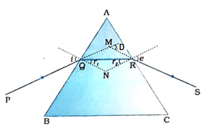**Expression for angle of deviation :**

In ΔQNR ,  ……(i)

In quadrilateral AQNR, 

As sum of four angles of a quadrilateral is 3600 So , ……….. (ii)

Comparing equations (i) and (ii)we get ;  ……. (iii)

Now in ΔMQR, 

 ( using exterior angle property )



 …….(iv) ( using equation (iii))

Equation (iv) gives expression for angle of deviation.

Here i= angle of incidence at 1st face AB , r1 = angle of refraction at 1st face

r2 = angle of incidence at 2nd face , e = angle of refraction t 2nd face or angle of emergence

* 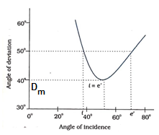**i~D curve of prism :** The experimental graph beween angle of incidence angle of deviation is called as i ~ D curve . This is as shown in the figure .

The grph shows that ;

1. For every value of D there exists two values of i . This is because if path of a ray through prism is reversed then i and e are interchanged , keeping (i + e ) unchanged and hence same D .
2. At the condition i=e , there is only one angle of incidence corresponding to a deviation . The deviation angle at this stage is minimum and denoted by Dm.

* **Minimum deviation conditions :** For minimum deviation i.e. for D = Dm , i = e . Hence r1 = r2 . So refracted ray in the prism is parallel to the base .

As  in minimum deviation condition r1 = r2 .

Hence r1 = r2 = A/2 .

Again as D = i+e-A and at minimum deviation condition i=e

Hence ; Dm = 2i – A i = ( A + Dm )/2 = e

* **Expression for refractive index of Prism :** Suppose prism is in air i.e. of refractive index 1 .

Let refractive index of prism = µ

Using Snell’s law for 1st face and 2nd face of prism , we have

………(i)

Using geometry it can be shown that ,

A = r1 + r2

At minimum deviation angle Dm , r1 = r2

Hence A = 2 r1  r1 = A/2 ……(ii)

Similarly in triangle MQR , it can be shown that D = i-r1+e-r2 = i+e-(r1+r2)=i+e-A

At minimum deviation angle D = Dm , i=e

Hence Dm = 2i – A  …… (iii)

Using equations (ii) and (iii) in equation (i) we get



This equation is called as prism formula .

* If refractive index of surrounding medium is µ1 and that of material of prism is µ2 , then prism formula will be ; 
* **Refraction through thin prism for very small angle of incidence :**

Suppose prism is in air i.e. of refractive index 1 .

Let refractive index of prism = µ

Using Snell’s law for 1st face and 2nd face of prism , we have

………(i)

For very small angle of incidence ; 

,  and 

Using the conditions in equation(i) we get . ….(ii)

Using geometry it can be shown that ,

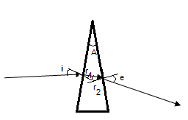 A = r1 + r2 …… (iii)

Similarly in triangle MQR , it can be shown that

 …….(iv)

Using equation (ii) in equation (iv) we get ,



This is the expression for angle of deviation for thin prism.

* **Total internal reflection in prism :** At second refracting surface of prism light travels from denser to rarer medium . If here angle of incidence (r2) 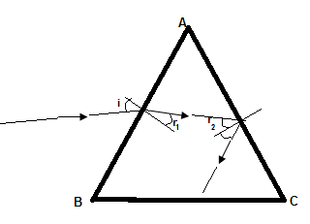exceeds critical angle (iC) then light is totally internally reflected in the prism .

So for total internal internal reflection at surface AC ,  …..(i)

As ………..(ii)

Again , By Snell’s law at surface AB we have ; 



{ Using equations (i) and (ii) }

 …………………………….(iii)

So for total internal to take place equation (iii) must be satisfied .

**Numerical : At what angle should a ray of light be incident on the face of a prism of refracting angle 750 and refractive index so that it just suffers total internal reflection at the other face ?**

**Solution :** At second face ray suffers just internal reflection means r2 = iC . As

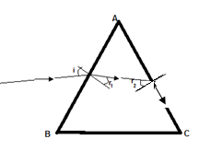 Since 

Again by Snell’s law at face AB ;



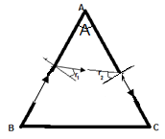**Numerical : A ray grazing along 1st face of a prism of refracting angle A enters into prism and also grazes along the other face also ? Obtain an expression for its refractive index .**

**Solution :** In this case i = e = 900 . 

As 

Again by Snell’s law in 1st face , 



**Numerical : A ray of light icident on te 1st face of an equilateral prism shows minimum deviation equal to 300 . Calculate the speed of light in the prism .**

**Solution :** By prism formula ; 



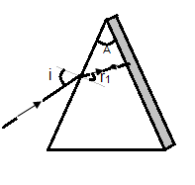**Numerical : One face of a prism with refracting angle 300 is coated with silver . A ray incident on the other face at an angle of 450 is refracted and reflected from the silver coated face and retraces its path . Find the refractive index of the material of the prism .**

**Solution :** As the ray retraces its path , hence it is striking the silvered surace perpendicularly .



As 

Using Snell’s law for refraction t 1st face we have; 

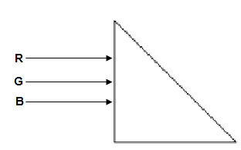**Numerical : A beam of light consisting rays of red ( R ) , green ( G ) and blue (B ) enter perpendicularly at one face of a right angled isosceles triangle in to its material . The material has refractive indices 1.39 , 1.44 and 1.47 for red , green and blue colours respectively . Trace their paths by showing proper reason . What would happen if the prism were an equillateral prism in place of right angled isosceles prism ?**

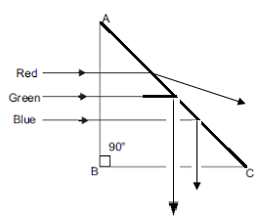**Solution :** In the figure all the rays enter into the prism undeviated at the 1st face and strike the 2nd face at angles of incidence 450 each .

For total internal reflection to be taken place at the 2nd face, condition reuired is



 ( Since sin iC =)



From the give refractive indices green and blue are satisfying the condition and hence get totally internally reflected . Only red colour light is transmitted .

If the prism was equilateral prism then for each ray at 2nd face angle of incidence = 600.

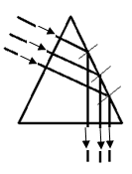For total internal reflection at 2nd face ; 

 ( Since sin iC =)



All the colours are satisfying the condition and hence all will suffer total internal reflection .

**Dispersion of light :**

* 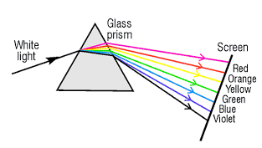Dispersion is the phenomenon due to which white light is splited up into constituent colours when passes through a prism .
* The pattern of seven colours ( VIBGYOR i.e. Violet , Indigo , Blue , Green, Yellow , Oange , Red ) is called as ***spectrum*** .
* **Cause of dispersion :** As from Cauchy’s formula ;  we can conclude that material has minimum refractive index for red (as largest wavelength ) and maximum refractive index for violet ( as smallest wave length ) .Again as angle of deviation is given by,  , hence out of constituent colours violet deviates highest ( as higest µ ) and red deviates least ( as least µ ) . So the white light is splited into constituent colours .
* **Angular dispersion :** The angular separation between highest deviation i.e. for violet (DV) and least deviation i.e. for red ( DR ) is called as angular dispersion .

It is given as; 

* **Dispersive power :** The ratio between angular deviation and mea devition of a prism is called as dispersive power () . So ,  Generally ; mean refractive index µ is the refractive index of yellow light .
* **Combination of prism :**

1. 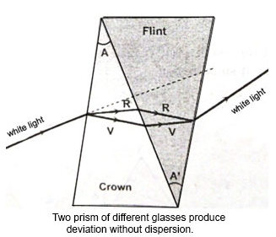**Deviation without dispersion :** i.e. 



This is the relation between angles of prisms of the prisms combined to produce deviation without dispersion . –ve sign is there because the prisms are to be arranged in opposite sense .

1. 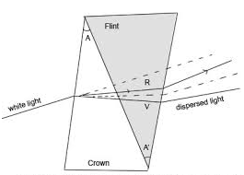**Dispersion without deviation:**

i.e. 



This is the relation between angles of prisms of the prisms combined to produce

dispersion without deviation . –ve sign is there because the prisms are to be arranged in opposite sense .

**Scattering of light :**

* When light strikes very small particles of size comparable to the wavelength of light then its direction is changed . This phenomenon is called as scattering of light .The particle that scatters the light is called as ***scatterer*** .
* **Rayleigh’s scattering :** The amount of scattering or the intensity of scattered light is inversely proportional to the fourth power of wave length .

i.e. ***I α 1/λ4 .***

* ***Blue colour of sky :*** The small particles of atmospheres of size comparable to wave length scatters the light . As according to Rayleigh scattering ***I α 1/λ4*** , then blue colour is scattered more strongly than red , green because of smaller wavelength . Although violet is scattered more strongly than blue , but our eyes are more sensitive towards blue than violet . So sky is blue.
* ***White colours of clouds :*** Large particles like dust and water droplets in cloud have very large size ( a >> λ ) . So they don’t scatter light and hence appear white .
* ***Appearance sun at different times in a day :*** (i) During sunrise and sun set sun remains near the horizon . So sun rays have to travel through a larger distance in the tmosphere at this time . Most of the blue and other shorter wavelengths are removed by scattering . The ***least*** ***scattered*** light reaching our eyes , **therefore sun looks reddish** .

***(ii)*** But at the noon time , sun is over head . So light rays from sun does not travel through a larger distance . So all colours reach in equal amount in our eye . So sun appear white during noon time .

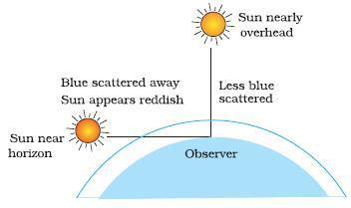

**Optical instruments :**

* Optical instruments are the devices used to view objects clearly with larger size.
* 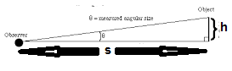Generally size of an object that appears to us is its angular size i.e. the angle(θ ) formed by it at our eye .

From figure, 

Where s = distance between object and observer which is between D ( i.e minimum distance of distinct vision = 25 cm ) and infinity .

If , =angular size of object that appears to naked eye .

* Optical instruments are used to enlrge this angular size . This can be made by ***(i) increasing the size of image and (ii) by reducing the apparent distance of image*** .
* The ratio between the angular sie of image and angular size of object is called as angular magnification or magnifying power . i.e. .
* **Difference between linear magnification and angular magnification :**

|  |  |
| --- | --- |
| **Linear magnification ( m)** | **Angular magnification (mθ)** |
| (i)It is the ratio between image height and object height . i.e. | (i) It is the ratio between angular size of imge and angular size of object . i.e. |
| (ii) m >1 means image height is greater than object height . | (ii) mθ>1 doesn’t mean image height is greater than object height. In some cases image height is less than object height also . |

* **Difference between Power of lens and magnifying power :**

|  |  |
| --- | --- |
| **Power of lens (P)** | **Magnifying power (mθ)** |
| (i)It is the reciprocal of focal length i.e. | (i) It is the ratio between angular size of imge and angular size of object . i.e. |
| (ii) Its unit is dioptre (D) | (ii) It is unitless . |
| (iii)It depends only on focal length and independent of image and object disance . | (iii)It depends on image and object positions. |

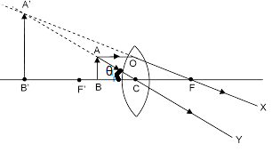**Simple microscope or magnifying glass or magnifier :**

* It is used to view magnified and erect image of very small objects like very small letters
* **Magnifying power of simple microscope :**

By defination ; ………(i)

As

From figure ,

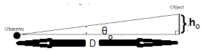 ….(ii)

Again ; when object is viewed through naked eye,



And  ………(iii)

Using equations (ii) and (iii) in equation (i) we get ,

 …………..(iv)

* **Linear magnification of simple microscope :**

By defination ; ………………………(v)

* **When final image is formed at minimum distance of distinct vision :**

i.e v = -D and u = -u by sign convention .

Then , 

By lens formula ,

Using v = - D and u = -u as per sign convention ; 

………….(vi)

This is the minimum angular magnification by mgnifying glass .

* **When final image is formed at infinity i.e. for normal adjustment :**

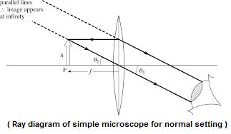i.e v = infinity and hence u= f

Using the conditions in equation (iv) we get ; ……(vii)

This is the minimum angular magnification by mgnifying glass .

* From expressions (iv) and (vii) it is clear that , to get more angular magnification , focal length of the lens should be smller .

**Numerical : A magnifying glass of focal length 10 cm is kept in front of an object at a distance 8 cm**

1. **Calculate the linear and angular magnification produced by the lens .**
2. **When will be the linear and angular magnification be equal .**
3. **Find the maximum and minimum angular magnification produced by the lens .**

**Solution :** (a) 

 .

(b)When final image is produced at minimum distance of distinct vision then both linear and angular magnification be equal .

( c ) Angular magnification will be maximum when final image is at D .



Angular magnification will be minimum when final image is at infinity .



**Compound microscope :**

* A realistic simple microscope can have a maximum angular maimum upto 9 .
* To have more magnification two co-axial convex lenses can be used . This is compound microscope .
* **Principle :** As it uses two lenses so one lens compounds the effect of other . Total magnification is the product of magnifications of the two .

**i.**e. 

* **Costruction :** A compound microscope uses two co-axial convex lenses with smaller focl lengths . One lens with smaller focal length (fO) and smaller aperature is held close to the object and is called as ***objective lens***. The other lens with comparatively greater focal length and greater aperature is held near eye to view final image and is called as ***eye piece*** .
* **Ray diagram :** The ray diagram of compound microscope is shown below .

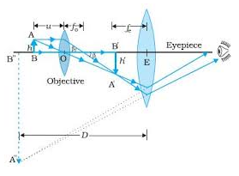

* **Working and determination of magnifying power :**

1. A very small object AB is kept very close to 1st principal focus of objective lens .
2. Objective lens produces a real , inverted and magnified image A’B’ beyond its 2F .

The magnification produced by objective lens is ; …..(i)

Where h’ = image height produced by objective = A’B’

h = object height for objective = AB

vO = image distance for objctive and uO = object height for objective

Since from figure we can observe that ;

 …….(ii) ( using equation (i))

Here L = distance between 2nd principal focus of objective and 1st pricipal focus of eye piece. Here image produced by objective is just after 1st principal focus .

Hence ;  ……….(iii)

1. Eye piece lens just behaves as a simple magnifier for the image A’B’ of eye piece . So final image is erect w.r.t. image of objective , but inverted w.r.t. the object AB . Hence angular magnification by eye piece for final image at least vision ; ……..(iv)
2. Total magnification or angular magnification for final image at least vision is

 ……..(v)

1. For normal set up final image is at infinity . So ……..(vi)

In this case total angular magnification is ; ..(vii)

Ray diagram for this case is shown below .

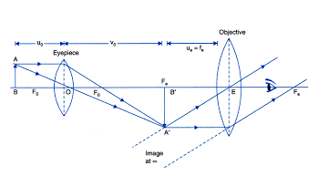

1. From equations (v) and (vii ) it is evident that , for a compound microscope focal lengths of objective and eye piece should be very small to have greater magnification .
2. **Difference between objective and eye piece of a microscope :**

|  |  |
| --- | --- |
| **Objective lens** | **Eye piece lens** |
| (i)Kept close to the object. | (i) Kept close to eye . |
| (ii)Small focal length and small aperature. | (ii) Comparatively large focal length and large aperature . |
| (iii)Always produce real and magnified image. | (iii) Produces virtual, erect and magnified image . |

**Numerical : A compound microscope consists of an objective lens of focal length 2.0 cm and an eye piece lens of focal length 6.25 cm separated by a distance of 15 cm . How far from the objective should an object be placed in order to obtain the final image at (a) the least distance of distinct vision(25 cm ) and (b) at infinity ?**

**What are the magnifying power of the microscope in each case ? (NCERT)**

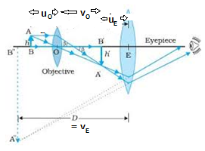**Solution :** (a) Given that , vE = - D = - 25 cm , fE = 6.25cm

By lens formula for eye piece ;





By lens formula for objective lens ;



Here ; 

OR ( other method of calculation of m )

Here L = separation between 2nd focus of objective and 1st focus of eye piece

= 15 cm – ( fO + fE ) = 15 cm – 8.25 cm = 6.75 cm

So , 

(b) Given that , vE = - D = - ∞ , fE = 6.25cm

By lens formula for eye piece ;





By lens formula for objective lens ;



Here ; 

**Numerical : An angular magnification of 30X is required for a compound microscope using an objective lens of focal length 1.25 cm and an eye piece lens of focal length 5 cm . How will set up the microscope ? (NCERT)**

**Solution :** Now for microscope , m = 30X

As final image is inverted , m = -30 X



By lens formula for objective lens ;



By lens formula for eye piece ;





So lenses should be separated by 11.7 cm and object should be kept 1.5 cm from objective lens

**Refracting type astronomical telescope :**

* A telescope is used to view distant objects closer .
* **Costruction :** A refracting type stronomical telescope uses two co-axial convex lenses . One lens with large focal length (fO) and larger aperature is held towards the object and is called as ***objective lens***. The other lens with comparatively smaller focal length and smaller aperature is held near eye to view final image and is called as ***eye piece*** .
* **Ray diagram :** (i) The ray diagram of refracting type stronomical telescope for normal adjustment is shown below .

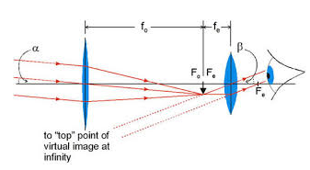

(ii) The ray diagram of refracting type stronomical telescope for final image at least distance of distinct vision is shown below .

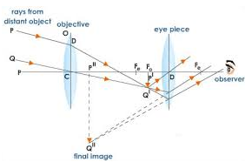

* **Working and determination of magnifying power for normal set up :**

1. Light from distant object enters into the objective and objective forms a real and diminished imageP’Q’ at its 2nd principal focus . The angular size of object is α . From figure ; . ( where h1 = height of P’Q’ )

As …….(i)

If object height is h and it lies at a very large distance r then ; .

So; h/r = h1/fO .

1. The 1st principal focus of eye piece coincides with 2nd principal focus of objective . So P’Q’ lies at 1st principal focus of eye piece . So final image is formed at infinity . The angular size of final image is β.

From figure ; . ( where h1 = height of P’Q’ )

As …….(ii)

1. So magnifying power or angular magnification of telescope for normal setting is ;  ….(iii)
2. Length of the telescope tube for normal set up ; ……(iv)

* **Working and determination of magnifying power for near point vision :**

1. Light from distant object enters into the objective and objective forms a real and diminished imageP’Q’ at its 2nd principal focus . The angular size of object is α . From figure ; . ( where h1 = height of P’Q’ )

As …….(i)

1. P’Q’ lies between the 1st principal focus of eye piece and lens . So eye piece produces virtual and erect image w.r.t. P’Q’ but inverted w.r.t the original object . The angular size of final image is β.

From figure ; . ( where h1 = height of P’Q’ )

As 

Using lens formula for eye piece ,..(ii)

1. So magnifying power or angular magnification of telescope for normal setting is ;  ….(iii) ( using equation(ii))
2. Length of the telescope tube for normal set up ;

……(iv) ( Using equation (ii))

* **Difference between objective and eye piece of a microscope :**

|  |  |
| --- | --- |
| **Objective lens** | **Eye piece lens** |
| (i)Kept towards the object. | (i) Kept close to eye . |
| (ii) Large focal length and large aperature. | (ii) Comparatively smaller focal length and smaller aperature . |
| (iii)Always produce real and Diminished image. | (iii) Produces virtual, erect and magnified image . |

**Reflecting type astronomical telescope :**

* This telescope works by forming image due to reflection .
* **Ray diagram :** Ray diagram of a reflecting type telescope ( Cassegrain telescope ) is shown below .

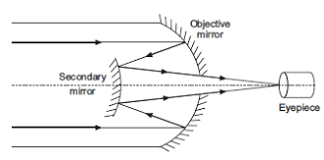

* Its magnifying power is ; 

Where = focal length of objective mirror and =focal length of eye piece

* **Advantages of reflecting type telescope over refracting type telescope :**

1. There is no chromatic abberation in a mirror .
2. By chosing parabolic reflecting surface spherical abebration is also removed in reflecting type telescope .
3. Less mechanical support is required to hold reflecting type telescope as they are very light .

* **Measure drawback in reflecting type telescope and remedies :**

Its measure drawback is that objective mirror focussing lights into telescope tube where observer and eyepiece are present . So some light must be obstructed .

This problem is shorted out by using a secondary convex mirror to reflect the converging beams from objective mirror into telescope tube as Cassegrain type telescope .

**Numericals : (a) A giant refracting telescope at an observatory has an objective lens of focal length 15m . If eye piece lens has focal length 1.0 cm , then what is the angular magnification ?**

**(b)If this telescope is used to view moon with diameter 3.48 x 106 m orbiting earth in circular orbit of radius 3.8 x 108 m, then find the diametre of the image of moon through the objective lens . ( NCERT)**

**Solution :** (a) 

(b)As angular size of moon at objective = agular size of image of moon through objective

 

= 

**Numericals : A telescope has objective lens of focal length 140cm and eye piece lens of focal length 5.0 cm . Calculate its magnifying power and tube length if (a) final image at minimum distance of distinct vision and (b) final image at infinity . ( NCERT)**

**Solution :** (a) 

And 

(b) 

And 

**Question: Some lenses are given with their specifications as shown in the table. Which lens will you prefer as objective and eye piece of (a) a telescope (b) compound microscope .**

**Explin the cause .**

|  |  |  |
| --- | --- | --- |
| **Lenses** | **Focal length ( in cm )** | **Aperature ( in cm)** |
| L1 | 1.0 | 5.0 |
| L2 | 2.0 | 8.0 |
| L3 | 10.0 | 20.0 |
| L4 | 100 | 80 |

**Answer :** (a) For telescope , focal length and aperature of objective lens are very large and of eye piece are very small . So L4 is preferred as objective lens and L1 is preferred as eye piece lens .

(b) For compound microscope , focal length and aperature of objective lens are very small and of eye piece are comparatively larger but not very large . Because to have more magnification focal lengths of both objective and eyepiece of compound microscope are reuired to be small ( As magnification is ; . So L1 is preferred as objective lens and L2 is preferred as eye piece lens .