| HISTORY| STUDY NOTES

Chapter- 13

The Nationalist Movement (1885-1919)

STUDY NOTES

After the Revolt of 1857 a feeling of Nationalism gradually spread across the country. Nationalism is a feeling of pride in one’s country. It also refers to the desire for freedom, felt by felt by people under foreign domination. This growing sense of nationalism led to the birth of the Nationalist Movement and eventual freedom from colonial rule.

# Reasons for the growth of Nationalism.

* Awakening of the Indians to their rich cultural heritage.

Western scholars like Max Muller and William Jones translated the Vedas, the Upanishads and other works of Indian literature in to English. Their research and writing made Indians aware of their great cultural heritage.

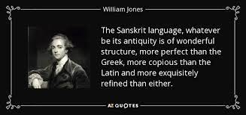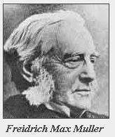

* Exposure to Western ideas of Democracy and nationalism
* The British introduced English education to train them to become clerks or occupy other low- level positions in government service. The new system of education exposed the Indian leaders to western ideas of Democracy and nationalism. They learnt of and were inspired by freedom struggles that had taken place in countries like America and France. English became a medium of exchange of thoughts and ideas for people from different parts of the country.
* Better means of transport and communication.

The rail and road networks and the post and telegraph systems established by the British helped to unite the Indians. People from different parts of the country

were able to communicate better with each other.

* Growth of the regional press and regional literature.

A major factor responsible for the rise of nationalism was the growth of vernacular journalism and literature. The regional press was able to

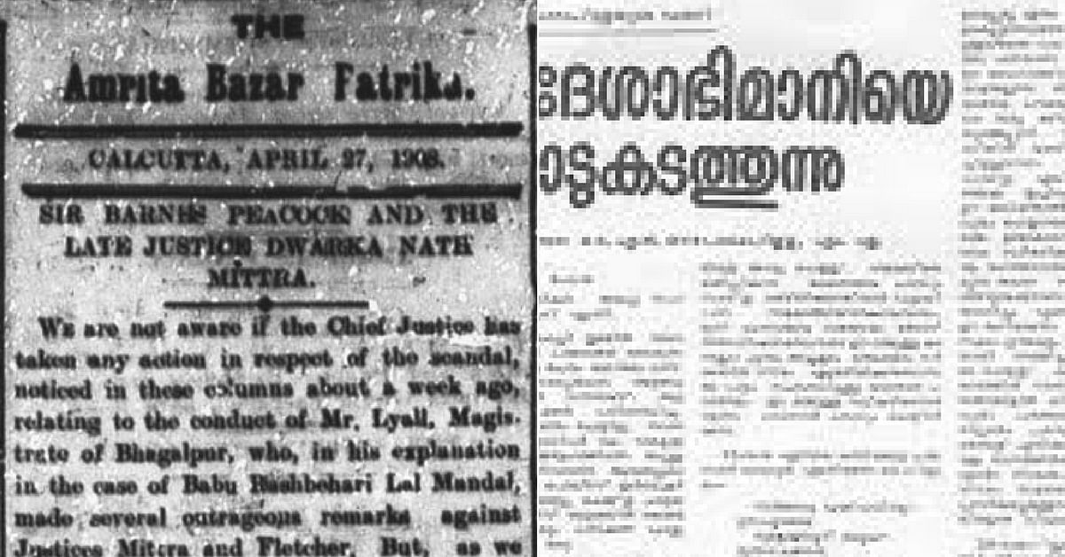

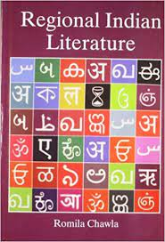

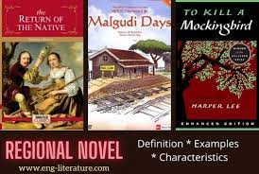

| HISTORY| STUDY NOTES

reach a far greater audience with its revolutionary ideas than the English language press.

* Economic exploitation by the British

The economic policies of the British had impoverished India. Recurring famines had occurred due to commercialization of agriculture ravaged the country side in the second half of 19th century aggravated the pathetic condition of the peasants. In 1877, the British Government held the Imperial Durbar in Delhi, at great cost to treasury even though the country was in the grip of terrible famine.

* Discrimination against Indians.



In 1878 British Government had reduced the age limit from 21 to 19 for the civil service examinations.

In the same year The Indian Arms Act was passed, which forbade Indians from possessing weapons.

The Vernacular press Act of 1878 forbade any provocative writings in regional languages against the government

The bill called Ilbert Bill passed in 1883 which aimed at establishing equality between Indian and English judges in Indian courts. The English Community and other Europeans in India reacted harshly, declaring that even the most the most highly educated Indians were unfit to try Europeans. So the British Government amended the Bill. The Indians were shocked and also realized that they too needed to organize themselves at a national level to get equal rights and to have their demands met by the government.

# The founding of the Indian National Congress.

In 1885, Allen Octavian Hume, a retired British Civil Servant, founded the Indian National Congress (INC).

The Congress was meant to be a safety valve for the Indians to ventilate their grievances. Some of the prominent leaders of the congress were

| HISTORY| STUDY NOTES

Dadabhai Naoroji, Pherozeshsh Mehta, S.Subramania Iyer, Rahimatullah,

W.C. Bannerjee and Dinshaw Wadia. The main aim of Congress was

* To seek the cooperation of all Indians.
* To eradicate prejudices of race, religion, caste etc.
* To discuss the major problems of India and come out with suggestions to solve them.
* To request the British to involve Indians while taking administrative decisions concerning India.

The leaders also decided to meet every year at the annual session to be held at different places and review the progress made. The second session, presided over by Dadabhai Naoroji, met at Calcutta. Dadabhai Naoroji was thrice elected president of the Congress- in 1886, 1893, and 1906. Because of his long association with India’s freedom struggle he is called the Grand Old Man of India.

# The Demand for Swaraj

Most of the Congress members were Indians and had faith in British. They only wanted gradual reforms. They aimed at better and friendly association with the British. They came to be called the Moderates.

The Moderates wanted the British to train Indians in the art of self-government. The Moderates included leaders like Surendra Nath Banerjee, Pherozeshsh Mehta, and Gopal Krishna Gokhale.

However, some Indian leaders like Bal Gangadhar Tilak in Maharashtra and Lala Lajpat Rai in Punjab demanded Swaraj or self-rule. Tilak made a forceful claim,’’Swaraj is my birth right and I shall have it ‘.’These leaders came to be called the extremists or the radicals, because they believed in adopting stronger measures to achieve freedom. Bipin Chandra Pal and Aurobindo Ghosh were the other prominent radical leaders.

| HISTORY| STUDY NOTES

# The Partition of Bengal ( 1905)

Lord Curzon became the governor general of India in 1898. He did his best to suppress the movement of extremist nationalism. In 1905 he partitioned Bengal. Bengal was the stronghold of the Congress. Curzon’s real reason was to separate East Bengal with its majority Muslim population, from the rest of Bengal and to weaken the Congress. It also served to divide the Hindus and the Muslims. This created a furore among the Indians. The leaders of Congress and the Nationalists leaders of Bengal firmly opposed the partition.

# The Boycott Movement and the Swadeshi Movement

The Congress leaders decided to introduce two anti- partition movement, The Boycott movement and The Swadeshi Movement. People decided to use only Indian goods and to boycott British goods. People gathered at crosswords, and burnt the imported clothes that they had. People picketed shops selling foreign goods. Imported sugar also was boycotted. This movement was called Boycott Movement.

People resolved to use only things made in India. This was called Swadeshi Movement. Swadeshi means ‘of one’s own country ‘. People began wearing cotton clothes made in India. The Boycott Movement affected British trade and industry. While the Swadeshi Movement helped local Indian Industries to prosper. The Congress leaders hoped that this would bring the British to their knees.

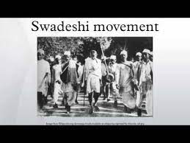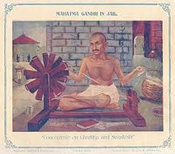

The British did not react the way the Indians expected. They put many people, including students in prison.

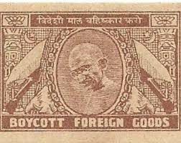

| HISTORY| STUDY NOTES

# The Split in the Congress

There were many differences of opinion between the Moderates and Radicals. The Radicals took Swaraj to mean total freedom from the British domination, while the moderates meant an increased role for Indians in British administration. The Moderates accepted the Swadeshi Movement but refused to accept the Boycott Movement. Radicals wanted to stop in the Congress in 1907.

# The Rise of Revolutionaries

In response to the anti- partition movement in Bengal, Lord Curzon’s administration unleashed a policy of repression. Thousands of swadeshi workers, students and ordinary people were prosecuted and imprisoned. The freedom of press was curbed. In 1908 nine prominent nationalist leaders of Bengal were deported. The people of Bengal were angered and frustrated. Some of them were soon drawn to more violent means of protest. They came to be called the Revolutionaries.

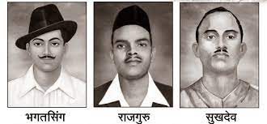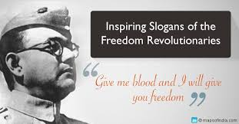

The Revolutionaries believed in using force to achieve their objective of independence from foreign rule. In the process they killed many British people. Prominent revolutionary leaders were Khudiram Bose, Praffulla Chaki in Bengal, VO Chidambarum Pillai and Vanchi Aiyar in Madras, VD Sarvarkar and Bhikaji Cama in Maharashtra.

# The Morley – Minto Reforms

The whole country was restless. The British responded by recalling Lord Curzon to England. Minto succeeded him as Viceroy of India, Along with John Morley, the secretary of State in England. Minto drew up a plan to win back the goodwill of the Indians. This plan came to known as India Council Act of 1909 or the Morley- Minto Reforms. According to this Act,

* + The number of elected members in the Imperial Legislative Council was increased.

| HISTORY| STUDY NOTES

* + Indians could now become members of the Provincial Legislative Council.
  + Separate electorates were introduced for the Muslims.

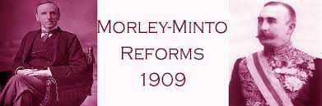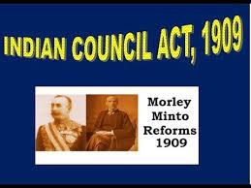

The Morley- Minto Reforms thus sowed the seeds of division between Hindus and Muslims. As a result of the separate electorates, the Muslims were further isolated from the growing freedom movement.

# The formation of the Muslim League (1906)

The formation of the Muslim League was instigated by the British as part of their policy of divide and rule. The Muslim leaders feared that if the British did leave India, Muslims would have no share in the Indian government. As a result of this feeling, some Muslim leaders set up a separate political organization in the form of the Muslim League.

# The Coronation Durbar (1911)

In 1911, a durbar was held in Delhi to commemorate the accession of King George V to the British throne. This occasion was chosen to make two major announcements. One was to reunite Bengal and the other was to shift the capital from Calcutta to Delhi.

The Home Rule League

Some of the Indian leaders realized that unless popular pressure was brought to bear upon the government, they would never have self-rule or home rule. So, between 1915 and 1916 two home rule leagues were started- one under the leadership of Lokmanya Tilak in Poona and the other under Annie Besant in Madras. Home Rule Leagues carried out intense propaganda all over the country in favor of the demand for self-rule, or home rule.

The unity between the congress and the league was brought about by the signing of the Congress- League Act popularly called the Luck now Pact in December 1916.

The Government of India Act (1919)

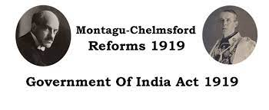

In July 1918 the Montagu-Chelmsford Reforms were announced. It was named after the secretary of state for India, Edwin Montagu and the viceroy, Lord Chelmsford. Its aim was to gradually develop responsible government in India, as a part of the British India. These reforms led to the enactment of the Government of India Act in 1919.

| HISTORY| STUDY NOTES

.