Chapter-5

LIGHT ENERGY

**STUDY NOTES**

**Refraction**

* **The change in the direction of path of light when it passes from one optical medium to another optical medium is called refraction of light.**
* 
* **When a light ray travels from rarer to denser medium:**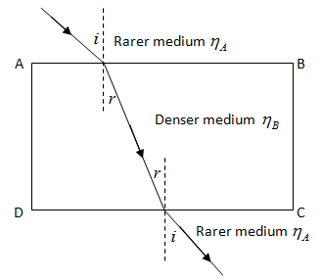
* **When a light ray travels from a denser to rarer medium:**
* 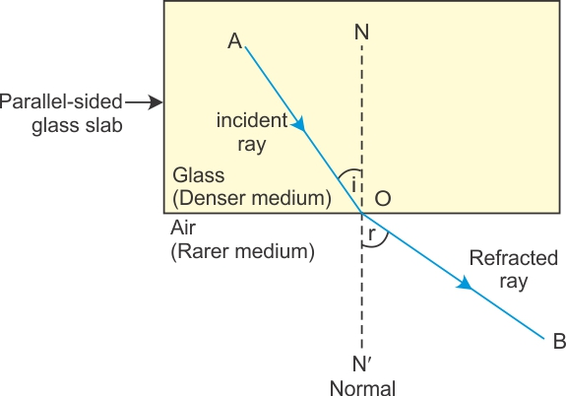

**When a light ray is incident normally on surface separating two media:**

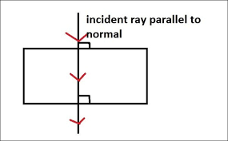

**Speed of light in different media**

* **Speed of light in air: 3×108 m/s.**
* **Speed of light in water: 2.25×108 m/s.**
* **Speed of light in glass: 2×108 m/s.**
* **Glass is optically denser than air or air is optically rarer than glass.**

**Terms related to refraction:**

* **Incident Ray**
* **Refracted ray**
* **Normal**
* **Angle of incidence**
* **Angle of refraction**

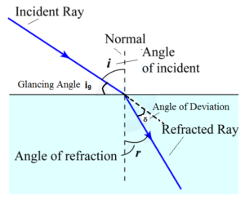

* **Incident Ray: The ray of light falling on the surface separating the two media is called the incident ray.**
* **Refracted ray: The ray of light travelling in other medium in the changed direction is called the refracted ray.**
* **Normal: The perpendicular drawn on the surface separating the two media at the point where the incident ray strikes it.**
* **Angle of incidence: The angle between the incident ray and the normal is called the angle of incidence.**
* **Angle of refraction: The angle between the refracted ray and the normal is called the angle of refraction.**

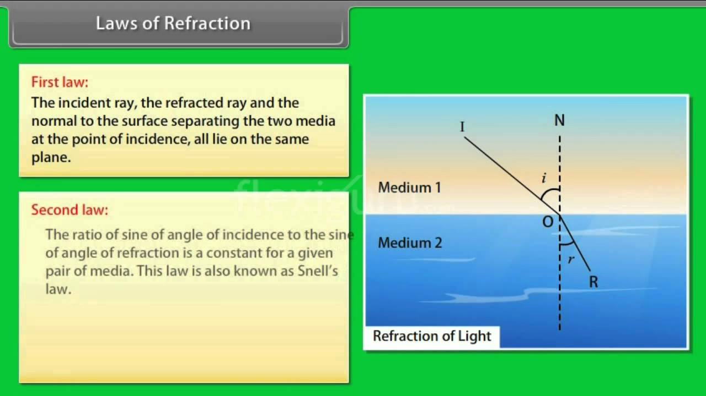

**Refractive Index:**

* **The ratio of sine of angle of incidence to sine of angle of refraction is known as refractive index.**

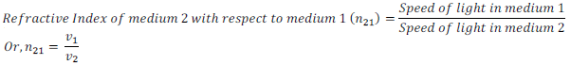

**E:\ODM\refraction-of-light-3.png**

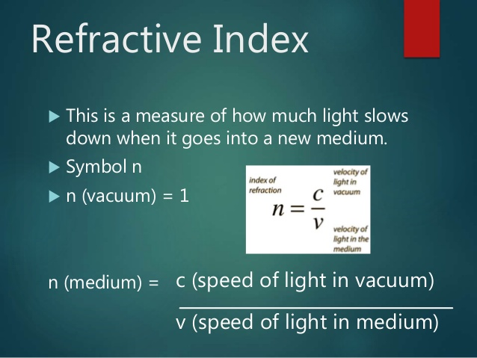

**EFFECTS OF REFRACTION (The depth of water in a vessel when seen from air appears to be less)**

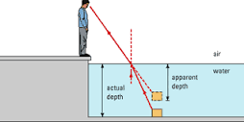

**Advance sunrise and delayed sunset:**

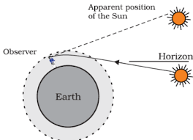

* **The sun is visible to us about two minutes before the actual sun rise and about two minutes after the actual sun set because of atmospheric refraction.**
* **When the sun is slightly below the horizon, the sun light come from less dense to denser air. So it is refracted downwards, due to this sun appears to be raised above the horizon and we can see it before the sun rise.**

**Mirage in a desert**

* 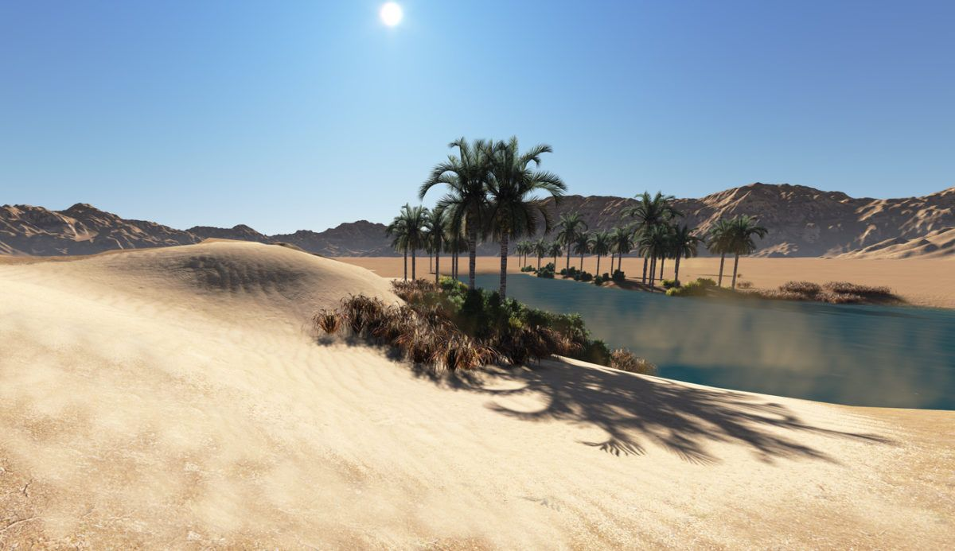
* **Some times in deserts, an inverted image of a tree is seen which gives a false impression of water under the tree. This is called a mirage.**
* **Cause: Refraction of light.**

**Refraction through a glass slab:**

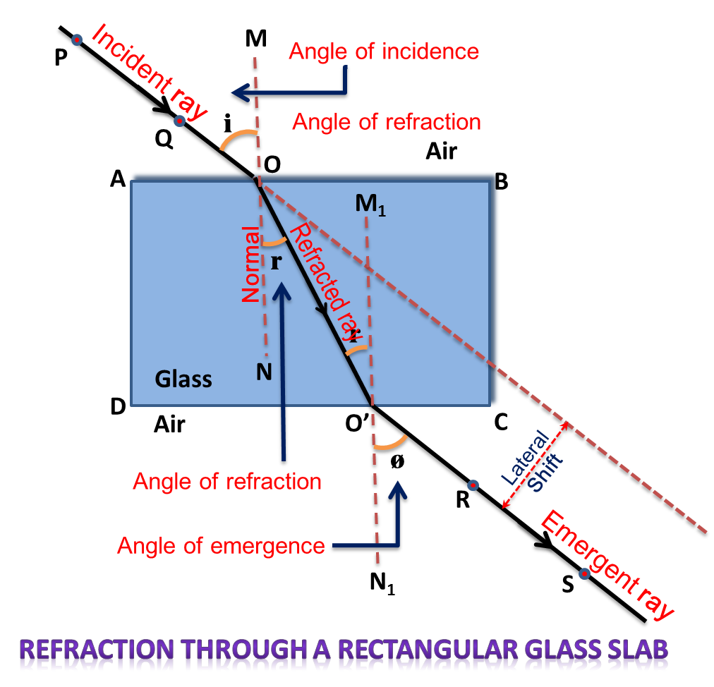

**Refraction through a prism:**

* **Prism is a transparent refracting medium bounded by at least two lateral surfaces , inclined to each other at a certain angle.**
* **It has two triangular bases and three rectangular lateral surfaces.**
* **The angle between two lateral surfaces is called angle of prism.**
* 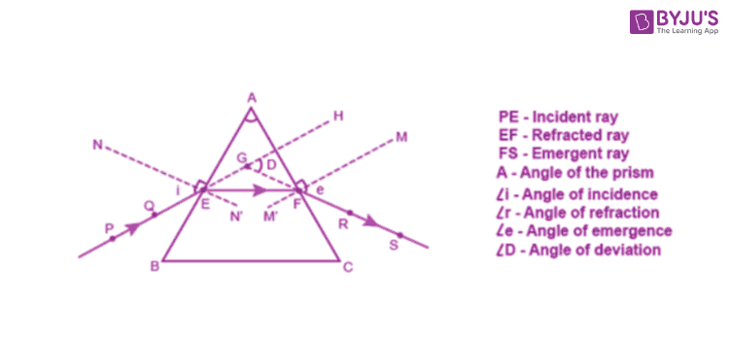

**Dispersion through a glass slab:**

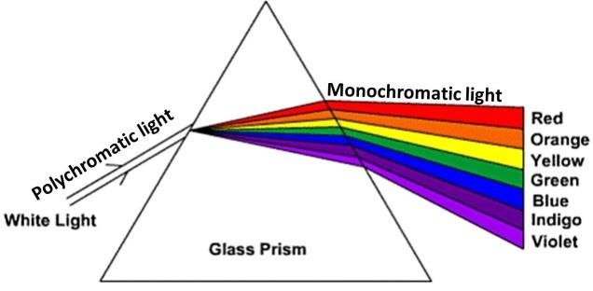

* **The phenomenon of splitting of white light into its constituent colors when passes through a prism is called dispersion**
* **The band of seven colors obtained are**
* **Violet**
* **Indigo**
* **Blue**
* **Green**
* **Yellow**
* **Orange**
* **Red.**

**This band of seven colors obtained by dispersion of light is called spectrum.**

**Causes of dispersion:**

* **Explain the causes of dispersion:**
* **Light rays of different colours , travel with the same speed in vacuum and air but in any other medium they travel with different speeds and bend through different angles which leads to dispersion of light.**
* 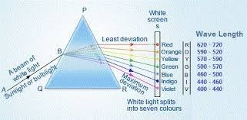

**Spherical mirrors :  
The mirrors which are the part of a sphere.**

* **Types of spherical mirror**

**Concave mirror**

**Convex mirror.**

* **Concave Mirror: The mirror whose reflecting surface is curved inwards is called a concave mirror.**
* **Convex Mirror: The mirror whose reflecting surface is curved outwards is known as a convex mirror**
* 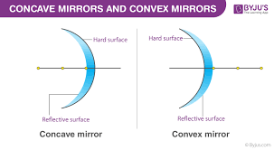

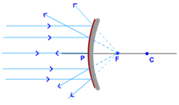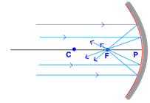

**Terms related to spherical mirrors**

* **Pole**
* **Focus**
* **Focal Length**
* **Centre of curvature**
* **Radius of curvature**
* **Principal Axis**

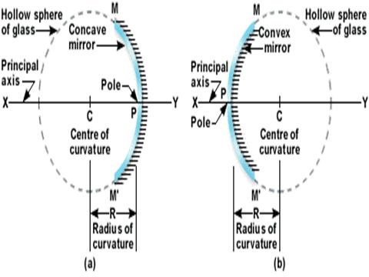

* **Pole: The geometric centre of the spherical surface of the mirror is called the pole of the mirror.**
* **Centre of curvature: It is the centre of the sphere of which the mirror is a part.**
* **Radius of curvature: It is the radius of the sphere of which the mirror is a part.**
* **Principal Axis: The imaginary line joining the pole and the centre of curvature.**
* **Focal length: The distance between the focus and the pole of the mirror is called the focal length of the mirror.**
* **Focal length = ½ x Radius of curvature.**
* **Focus of a concave mirror: A point on the principal axis at which the light rays incident parallel to the principal axis converge after reflection from the mirror.**
* **Focus of a convex mirror: A point on the principal axis at which the light rays incident parallel to the principal axis appear to meet after reflection from the mirror.**

**RULES FOR DRAWING RAY DIAGRAMS**

**RULE:1**

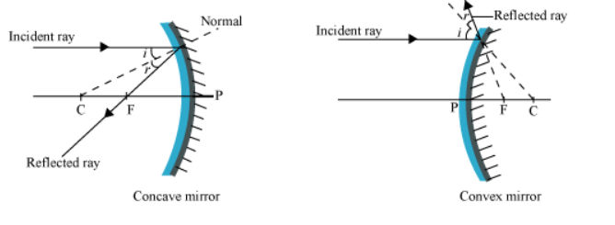

**Rule -2**

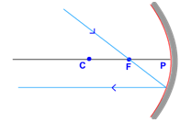

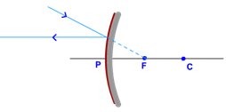

**Rule – 3**

**IMAGE FORMATION BY A CONCAVE MIRROR**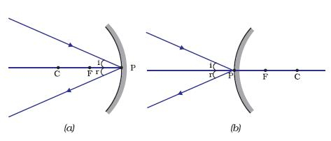

**Image formation by concave mirrors:**

1. **When the object is at infinity**

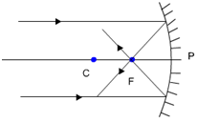

**2. When the object is beyond C**

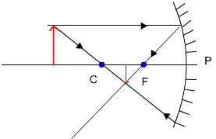

**3. When the object is at C:**

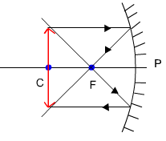

**4. When the object is between C and F;**

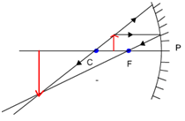

**5. Object at Principal Focus (F):**

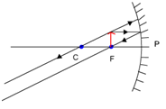

**6. Object between F and C:**

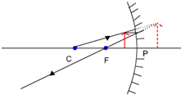

**Image formation by convex mirrors:**

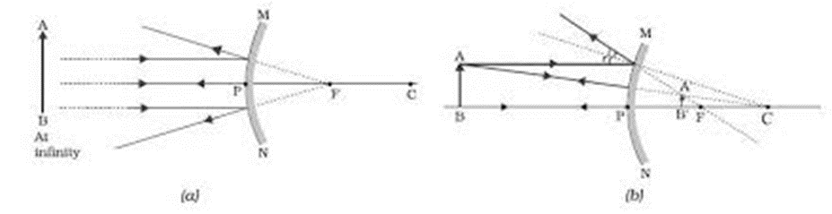

**Uses of concave mirrors:**

* **1. As shaving mirror.**
* **As a reflector.**
* **As a doctors head mirror.**
* **To converge solar radiations in a solar cooker.**
* **In flood lights as a reflector.**

**Uses of convex mirrors:**

* **1. As rear view mirror**
* **As reflector in street lamps.**
* **As a vigilance or anti theft mirror.**

**\*\*\*\*\*\*\*\*\*\*\*\*\*\*\***