

The Union Legislature

- the Parliament

**SUBJECT : SOCIAL SCIENCE**

**CHAPTER NUMBER: 3**

**CHAPTER NAME : THE UNION LEGISLATURE- THE PARLIAMENT**

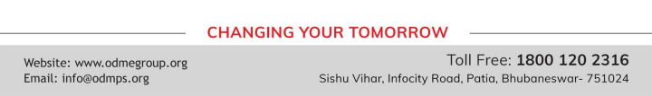

**Session-IV**

A Committee from among the members will be set up by the speaker. They belong to various political parties. The committee will scrutinise the bill and understand its positive and negative implications

**Third Reading**- The bill is drafted finally after the modifications and put to vote. If the majority approves it is passed. Then it passes to Rajya sabha.There also the same process will be followed.

Finally it is sent to President for Signature. If he put the signature the Bill becomes a law.

**Different methods to checking the Executives:**

**Question Hour, Zero Hour, Adjournment Motion , No-Confidence Motion , Impeachment**

**Question Hour** – The first hour of every sitting parliament is known as Question Hour.

There are 3 types of Questions

**• Starred Questions**- Questions with an asterisk mark are known as Starred. It requires oral Answer. **• Unstarred questions**- The Questions without an asterisk mark are known as unstarred questions. It needs written Answer.

**• Supplementary Questions**

**Zero Hour** -The period after the Question Hour and before the beginning of the rest of the days work is known as Zero Period. Members can raise questions of public interest during this time.

**Session-IV**

**Adjournment Motion**-It means that the current topic of discussion can be postponed and another topic of greater importance is taken up for discussion during the Adjournment Motion. Members have the right to know about the various aspects of the Govt’s policies.

**No Confidence Motion**-If the parliament loses its confidence in the Council of Ministers and its functioning, a motion of No- Confidence can be introduced in the Lok Sabha and it is passed with a simple majority , the Prime Minister and Council of Ministers must resign collectively.

**Impeachment**— Impeachment is the process by which The Legislature can remove the president of India from office for the violation of the Constitution



**THANKING YOU**

**ODM EDUCATIONAL GROUP**