

**WELCOME TO THE VIRTUAL CLASS**

**SOCIAL SCIENCE** 

**SUBJECT : HISTORY**

**CHAPTER NUMBER: 02**

**CHAPTER NAME : NATIONALISM IN INDIA**

**PPT: 6 of 6**

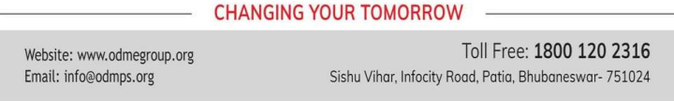

IMAGE OF BHARATMATA

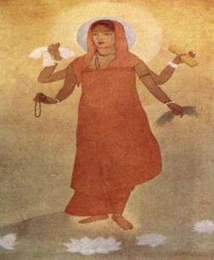

VANDE MATARAM

• It was a prayer to Bharat Mata written by Bankim Chadra Chattopadhyay. 

• Vande Mataram became the war cry of the Indians. • It was later included in his novel Anandamath



VANDE MATARAM

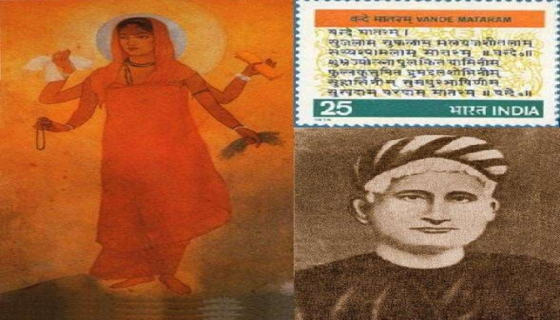

NATIONAL FLAG

• During the Swadeshi Movement a tricolor flag (red, green and yellow) was developed. It had 8 lotuses representing the 8 provinces of the British India. It also had crescent moon which represented Hindus and Muslims. 

• In 1921, Gandhiji designed the Swaraj flag. It was also a tricolor flag (red, green and white). It had a spinning

wheel which represent the Gandhian idea of Self Help.

• The flag became a symbol of the Nation. It created the feeling of oneness. The people carried flag in

protest marches and rallies



NATIONAL FLAG

SWADESHI FLAG SAWARAJ FLAG



**REDISCOVERY OF INDIA’S**

**PAST**

• The British considered Indians backward and primitive. They said that the Indians were not capable of ruling 

themselves. 

• In the 19th century, some educated Indians started the efforts of rediscover India’s great achievements. They

rediscovered the achievements made by the Indians in art, architecture, science, mathematics, religion, culture, law, philosophy, crafts and trade.

• Knowledge about the great achievements of Indians created national pride, self confidence and patriotism

among the Indians.



FOLKLORE OF SOUTHERN 

INDIA





REVIVAL OF FOLKLORE

• Nationalists toured the villages to collect the folk songs and legends. 

• Rabindranath Tagore collected a number of folk songs and legends. 

• In Madras, Natesa Sastri published a four volume collection of tamil folk tales (The Folklore of Southern India).

• The folk songs and legends gave a true picture of Indian culture. They showed there all thoughts and characteristics of Indians.

• They created National Pride among the people.



**THANKING YOU**

**ODM EDUCATIONAL GROUP**

