RURAL LIFE AND SOCIETY|HISTORY| STUDY NOTES

Chapter- 4( modified)

RURAL LIFE AND SOCIETY

**STUDY NOTES**

Introduction:

In the olden days in India, land was held for life. Farmers cultivated a piece of land for generations. Nobody could evict them so long as they paid a part of their produce as tax. Villages were largely self-sufficient. 

During the rule of Sher Shah Suri land was measured and pattas were given for the first time. Revenue was charged depending on the fertility of the soil.

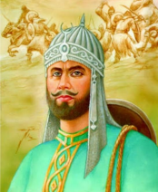

The Land Revenue policy under the British

The British East India Company started to take land revenue and they demanded a fixed amount in cash. To pay the amount farmers had to cultivate cash crops like cotton, poppy, Indigo which brought in more money than food crops like wheat and rice. Now the Indian villages were no longer self-sufficient.

ODM Educational Group Page 1

**[RURAL LIFE AND SOCIETY]** | HISTORY| STUDY NOTES

In an effort to streamline the process the British started three forms of revenue collection in India.

1. Permanent Settlement of Bengal

2. Ryotwari System

3. Mahalwari System

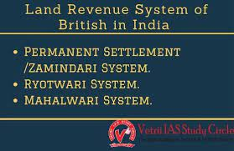

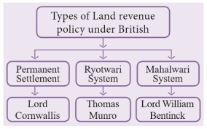

The new revenue collectors were Zamindars. 

Permanent Settlement of Bengal

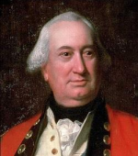

In 1793 Lord Cornwallis introduced the permanent settlement of Bengal. The Zamindars were required to pay a fixed amount in cash on a fixed date as land revenue to the treasury, irrespective of what they could collect. Many Zamindars benefitted more than either the company or the peasants.

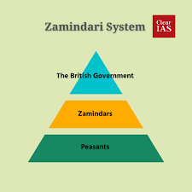

Advantages for the British



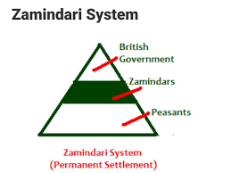

ODM Educational Group Page 2

**[Rural life and society]** | SUBJECT NAME| STUDY NOTES

1. Zamindars turned out to be firm supporters of the British

2. By fixing the land revenue the British government ensured that it received the same fixed amount on a fixed date.

3. It was easier to deal with few Zamindars than with hundreds of farmers

.Disadvantages for the farmers

1. The Zamindars ill treated the farmers to extract the revenue

2. Small farmers who either sell or mortgage their lands to pay the revenue became landless laborers.

3. Many Land owners were evicted from their land by the British because they did not have pattas to prove their ownership.

4. To meet the increasing expenses the Government had to increase the tax in other provinces.

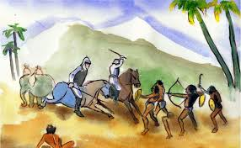

Permanent Settlement was introduced in Bengal, Bihar, Odisha and coastal Andhra Pradesh, It was abolished in 1955.

The Ryotwari System

ODM Educational Group Page 3

**[RURAL LIFE AND SOCIETY]** | HISTORY| STUDY NOTES

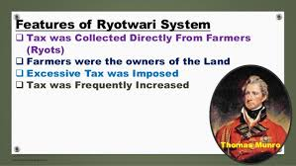

It was introduced in the Madras and Bombay Presidencies between 1792 and 1827. According to this system the middlemen or the zamindars were removed and settlement was made directly between the company and the cultivator (Ryot). They had to pay the government about half the value of the crop. The revenue amount was revised after 20-30 years depending on the fertility of the soil.

The Mahalwari System

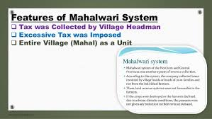

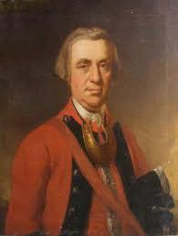

It was introduced in parts of Uttar Pradesh, parts of central India, the North West province and parts of Punjab.

According to this system the settlement was made between landlords, village headman and the government. The landlords and the village headman were jointly responsible for the payment of the revenue to the company. The revenue was fixed for a period of 20-30 years after which it was revised.

ODM Educational Group Page 4

**[RURAL LIFE AND SOCIETY]** | HISTORY| STUDY NOTES

The impact of the revenue systems on the cultivator

1. Impoverishment of cultivators

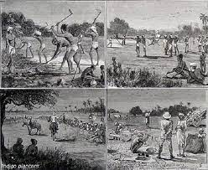

The revenue charges were so high, it led to the impoverishment of the cultivators. They were driven into debt at the hands of the money lenders or became landless laborers.

2. Fragmentation of Land Holdings

AUCTION OF LAND HOLDINGS

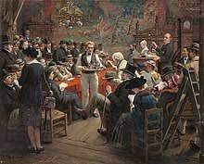

As the farmers found themselves unable to pay the revenue they auctioned or sold off their land part by part. This led to the fragmentation and subdivision of land.

3. Rise of absentee landlord

The landowners who were unable to pay the high tax were auctioned off to the highest bidder. The people who bought these lands were often rich traders from cities and towns. They rarely visited their farm land and had no interest in it. These absentee landlords were much harsher on the local farmers than the traditional zamindars.

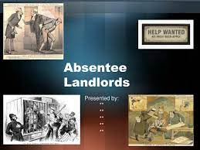

4. Commercialization of Agriculture

Since the cash crops provided raw materials for the Industry the Britishers encouraged the farmers to cultivate cash crops at the cost of food grains, It resulted in food shortage.

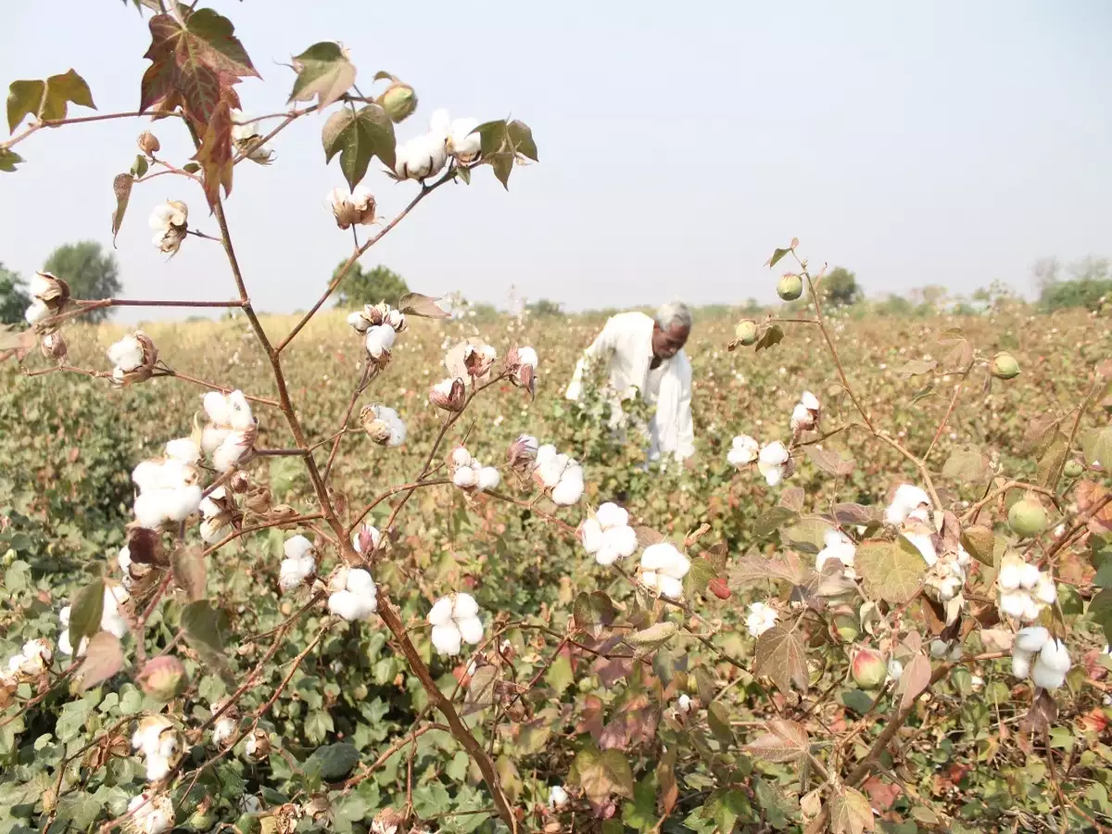



5. Neglect of land reforms

The British introduced private ownership of land to ensure steady revenue and to motivate the farmers to increase the output. However the landlords were either absentee landlord with no interest to improve the land or were too poor to carry

out reforms. This resulted in steady erosion in the quality of land and the life of the farmers.



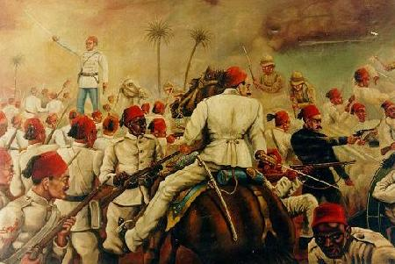

Peasant Revolt

The extreme poverty of the peasants drove them to revolt. The famous two revolts were

1. The Churs Revolt of Bihar and Bengal

2. The Moplah Revolt of Kerala

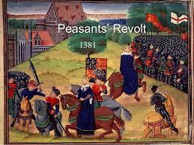

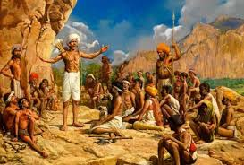

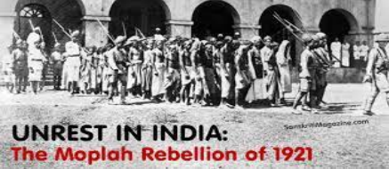



ODM Educational Group Page 5

**[RURAL LIFE AND SOCIETY]** | HISTORY| STUDY NOTES



ODM Educational Group Page 6