1.Write the location of master gland. Why it is named so?

Ans Your pituitary (hypophysis) is a endocrine gland at the base of your brain, behind the bridge of your nose and directly below your hypothalamus. The pituitary gland is called the "master" gland of the endocrine system because it controls the functions of many of the other endocrine glands.

2. Draw the flowchart of the hormones secreted by Pituitary gland.

Ans

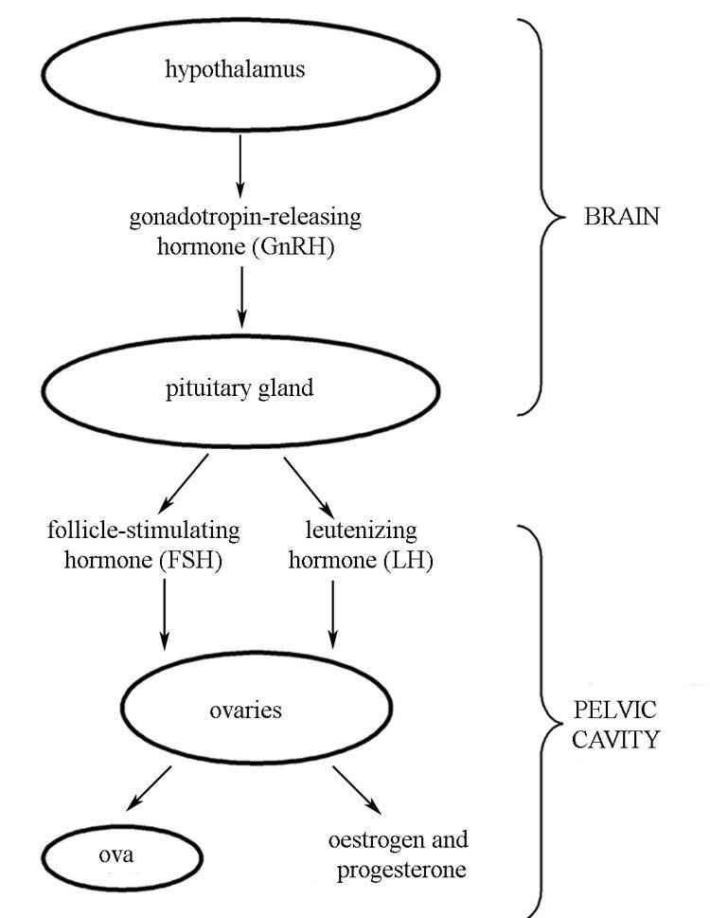

3. Write in a tabular form name of the gland, location and hormones secreted by them.

Ans

