Dr. Prasanta Kumar Padhi

Dept of Humanities

Veer Surendra Sai University of Technology

Burla, Odisha

16th February 2922

The Principal

ODM Public school

Bhubaneswar

Sub- Application for change of Plan from Residential to Day Boarding

Dear Sir,

I would like to bring to your kind notice that my daughter Pragnya Pratikshya Padhi, Admission No- 12442 is pursuing her XI (science) as a residential student in your esteemed institute. Because of certain health conditions she is going to stay with her mother nearby your school. Therefore I would like to change her study plan to **Day Boarding** for her Class XII.

With warm Regards,

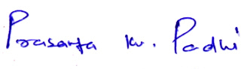

PK Padhi